System Upgrade: 2nd Level Leap-Frog Method

The purpose of this task/project is to take a system on an older version of zVM and upgrade it without extended downtime periods. Essentially, anything modified on the Source System will be carried over through file editing, DDR, Flashcopy and FTP to the Target system.  
In preparation the admin will create and install a new zVM system on the current version as a fresh second level system. Create, Install and tailor the system as you would any other. After the new target base system is in place the; System Config, Extent Control, Authfor Control and other system parameter type files should be tailored to incorporate any features, connections or links from the Source system. The admin will take the user directory from the Source system and combine it with a modern version’s direct file to remove old VM’s and add new VM’s as well as the users from the Source system. After merging the direct files to create a User Input and tailoring the Target system files the Target system will replace the Source system as the IPL device from the HMC.

Project Overview

* **Source System** “The Old” Source system you intend to *apply* the upgrade to.
* **Target System** “The New” Target system that is intended to be the upgraded final product version of information from the Source System applied to a modern zVM version.

1. Identify DASD locations for Target System, gather information.
   1. Fill out worksheets with Target system’s planned information.

* + 1. Copy over network addresses, gateways, IP etc. all from Source System’s TCPMAINT 592 TCPIP Profile, unique info from System Config and keep this information for system tailoring and worksheets.  
       *Use a temporary IP until REIPLing with the new version of zVM on the Target System. Alternatively, use DEFINE MDISK for targeted file editing.

1. Install Target System’s current/modern zVM version.

* 1. Install zVM.

* 1. Install DIRMAINT.
  2. Install TCPIP.

* 1. Install FTP.

1. Make a copy of: System Config (Pmaint cf0), Extent Control (DIRM) and Authfor Control (DIRM), TCPIP Profile (TCPMAINT 198) and edit them with XEDIT to contain parameters and information from the Source System.

* 1. DASD Allocation (ex. Page volumes)

* 1. Device Ranges

* 1. Features Statements

* 1. Timezones

* 1. User_Volume statements

* 1. Virtual Switch Definitions

1. Utilize/write scripts to merge the Source System and Target System user direct(User Input, User Withpass, the master file) files to remove old IBM VM’s and replace them with the new versions as well as the Source System’s users and machines.
   1. Bring these changes online and apply them with DIRM as a batch to the Target System.

***----------------After Scheduling Downtime!----------------***

1. Flashcopy and backup the Linux and virtual machine guests’ DASD contents with a fresh backup. Then migrate the user data to the Target System after specifying the Target System’s DASD to replace the Source System as the IPL DASD.
2. Verify with other teams that all guests are functional and have a cookie.

Worksheets

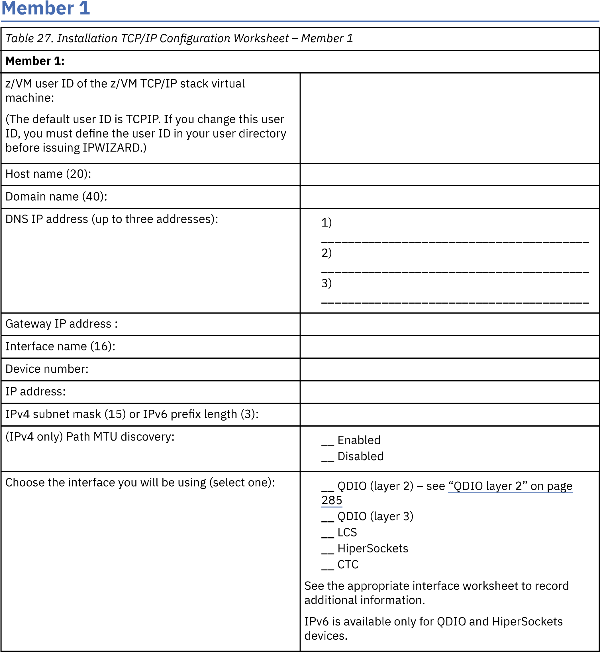

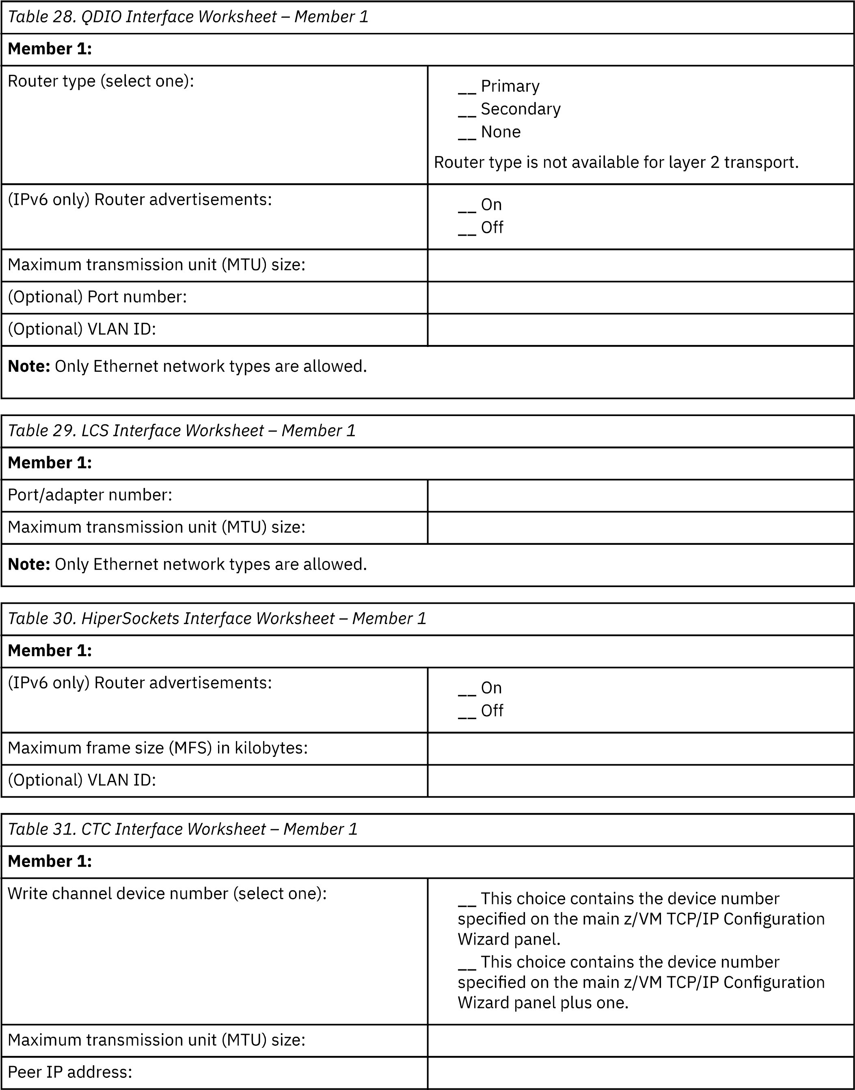

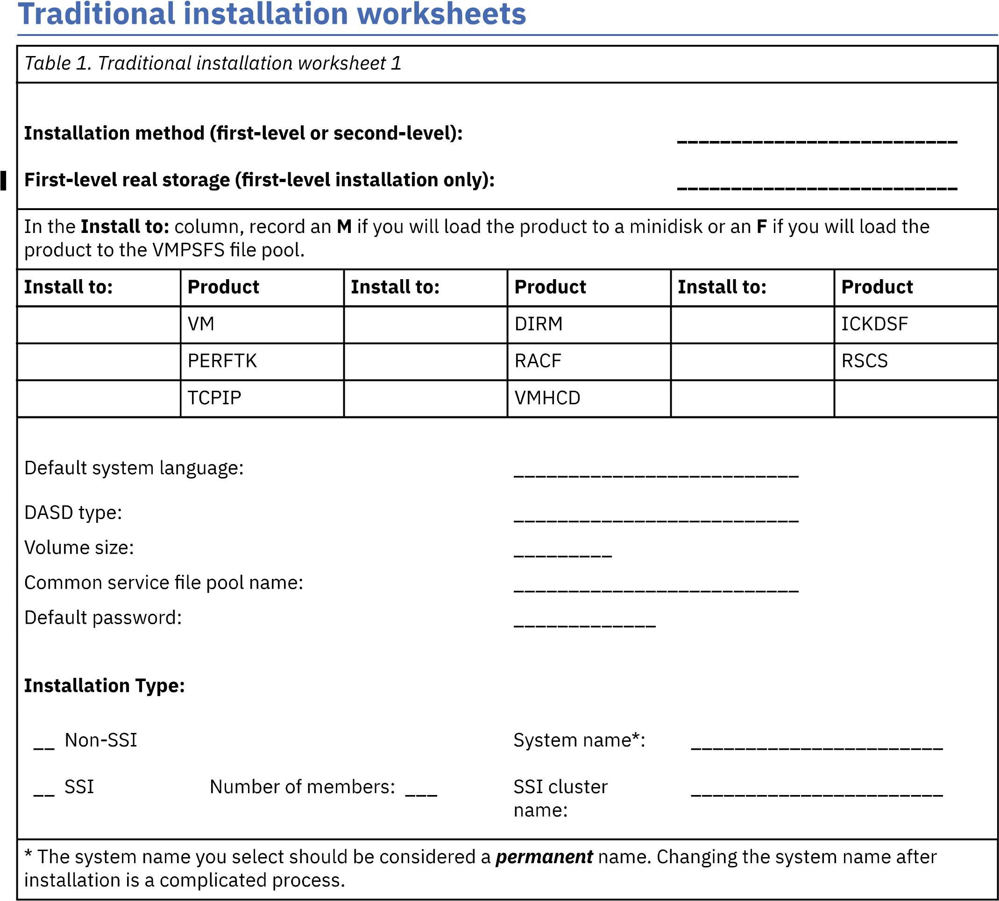

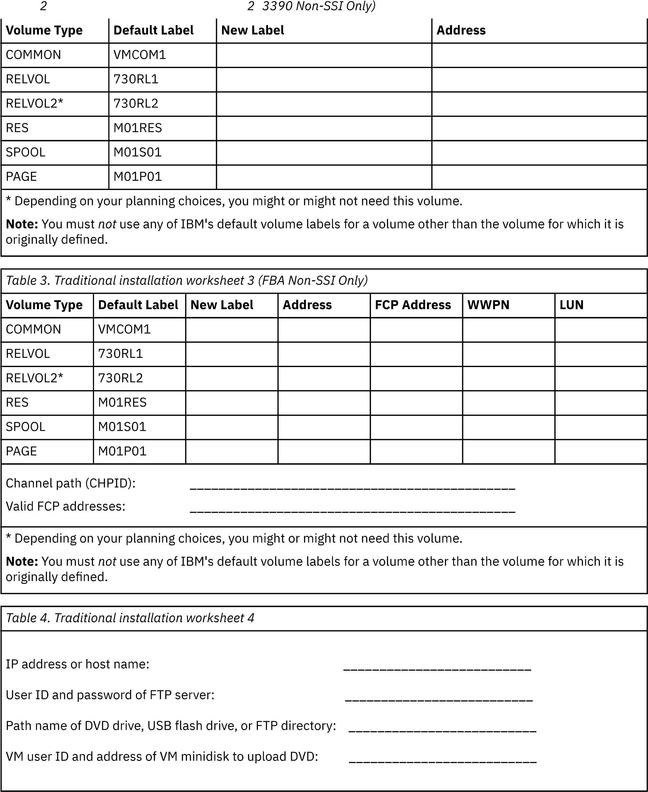

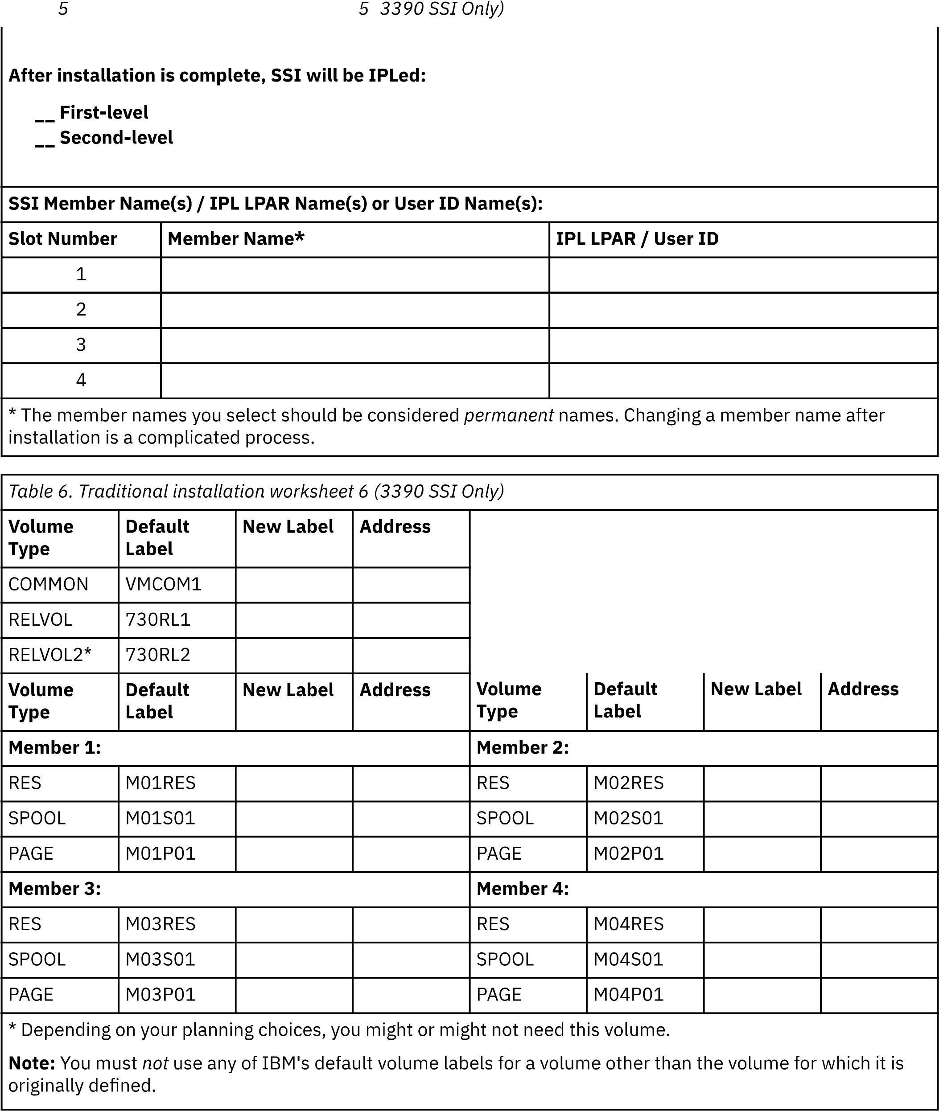

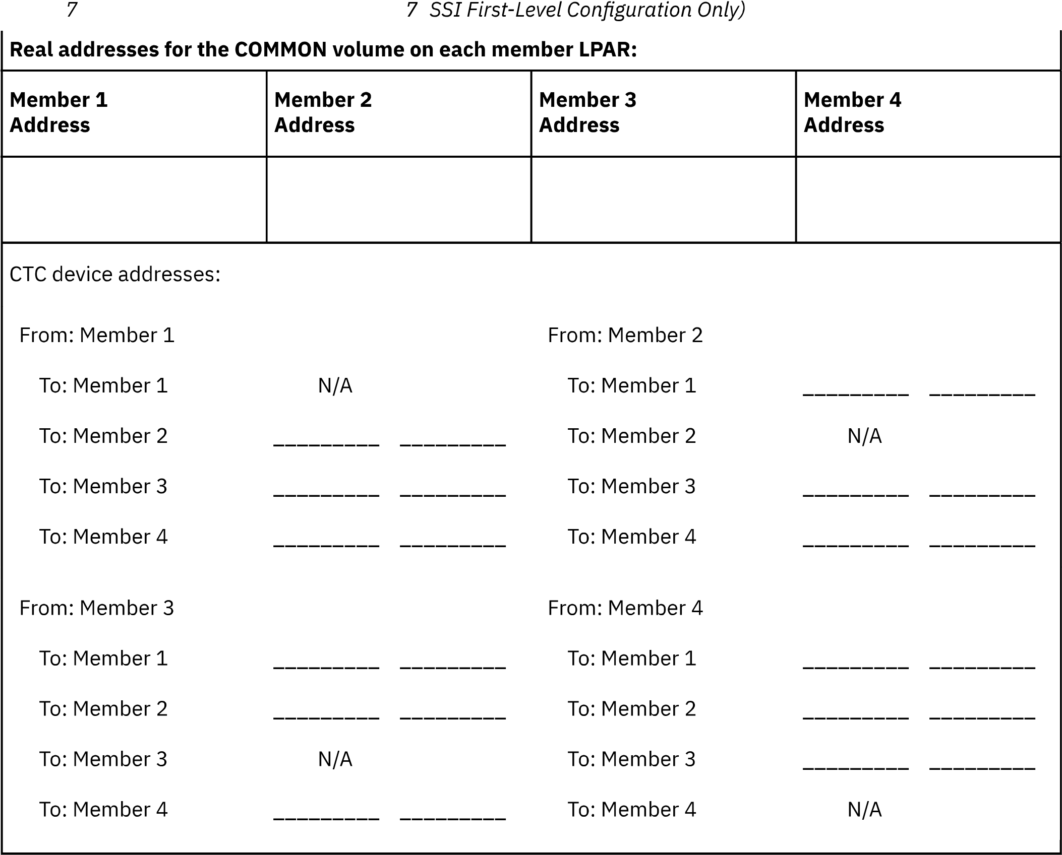

Worksheets

Copy over

VMLINK Example

1. Establish the virtual link and if necessary use an option for write privileges.
   1. VMLINK user mdisk (option  
      vmlink pmaint cf0  
      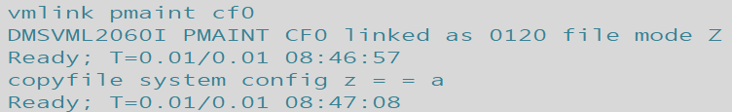
      1. For write privileges specify write as the option.  
         vmlink pmaint cf0 (write
2. Copy the file renaming it or changing the filetype and specifying the filemode for the disk that the user would like the file saved to. The first set of Filename, Filetype, Filemode are for the target file and the second set of fn ft and fm set the new copies file settings.
   1. Copyfile filename filetype filemode filetype filename filemode  
      copyfile system config z = = a  
      

Copy over

Install_zVM

zVM 7.3 System Installation Second Level

This document covers the necessary preparation and steps required to install zVM 7.3 to a mainframe LPAR. This method uses an existing first level zVM operating system to hold install files, install the files to DASD and finally IPL from those DASD from within the first level with a privileged user. That makes this an ideal means to tailor a system prior to putting it into production.

Requisite Information Pre) Fill out worksheets.  
DASD Mod : 1) Create container/IPL User for 2nd Level.   
IP Address : 2) FTP Files to zVM.  
Started : 3) Log into the Install User.  
Gateway : 4) Run **INSTPLAN.**  
Subnet Mask : 5) Fill and submit **INSTPLAN** panels.  
System Name : 6) Attach any additional devices and run **INSTALL** on system.  
Filepool Name: 7) Login with Maintenance User.  
HMC Account : 8) Subsequent IPL’s.  
 Post) Start Utility Installs after inspecting new system.

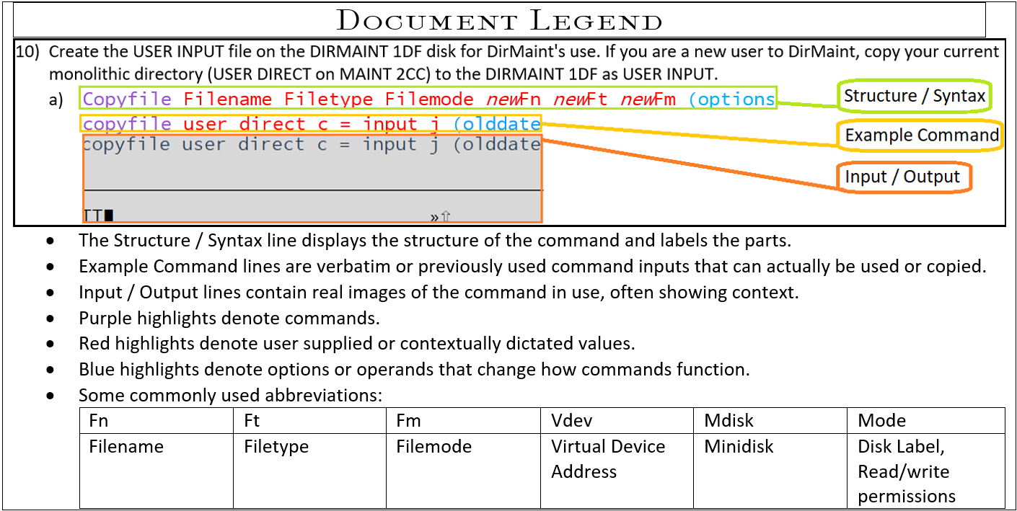

Detailed Instruction:

1. When installing a second level system you must first create a user to contain the installation files. (See User Creation.) You will also need the user to be fitted with:
   1. Access to the INSTPIPE MODULE on your current system. The module was shipped on the MAINT 193 minidisk.
   2. Privilege class G.
   3. Privilege class B, if installation DASD volumes are not already attached to your installation user ID.
   4. At least 128 MB of virtual storage.
   5. An MDISK with 8,000 cylinders of storage available. (ex. Name: 5555)
   6. A 191 read/write minidisk accessed as file mode A.
   7. If installing from a CMS-formatted minidisk (referred to as "From a VM Minidisk"), write access to the minidisk where the files will be loaded.
   8. A 2222 read/write minidisk, matching the supported DASD type (3390 or FBA) of your installation media, that is exactly 10 cylinders (3390.)
   9. A 24CC read/write minidisk, matching the supported DASD type (3390 or FBA) of your installation media, that is exactly 10 cylinders (3390.)
   10. A 2CF0 read/write minidisk, matching the supported DASD type (3390 or FBA) of your installation media, that is exactly 120 cylinders (3390.)
       1. Ex. 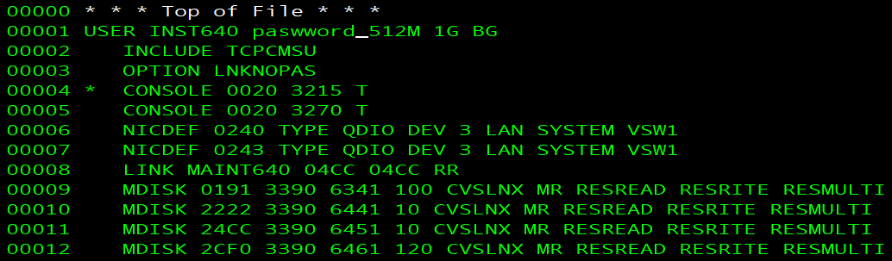

1. FTP the installation files over to the container MDISK for the Install User to access. (See –hyperlink FTPing How To.)
   1. Be sure the files are the correct size and length (part of the FTP instructions sets this.)
   2. Verify the file type is IMAGE rather than $default. If file type is $default use the provided command below to rename the files.
      1. **Rename filename filetype filemode newFN newFT newFM  
         rename * $default w = image =**

1. Log into your privileged Installation User. (Ex. Here is INST640)
   1. Spool the console to make sure it is empty, started, and spooled to the reader.
      1. **spool console close start \***  
         RDR FILE *filenum* SENT FROM
   2. Verify that you have a 2222 read/write minidisk
      1. Q v 2222  
         
   3. Link and Access install user’s 5555 mdisk as filemode w.
      1. Link user mdisk mdisk filemode  
         link xSystemx 5555 5555 wr  
         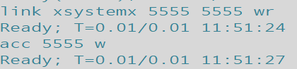
   4. Access the MDISK as W for the upcoming command.
      1. Access mdisk filemode  
         Acc 5555 W  
         
   5. Verify that INSTPIPE MODULE exists in your search order. If it says not found, simply access Maint 193.
      1. Listfile filename filetype filemode  
         Listfile instpipe module *  
         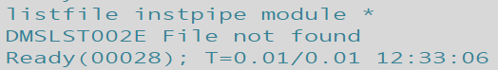
      2. vmlink user mdisk  
         vmlink maint 193  
         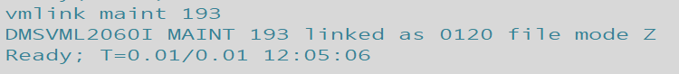
      3. (Desired output shown below)  
         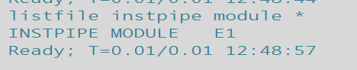
   6. Copy necessary files for DVDPRIME to 2222 MDISK by running INSTPIPE.
      1. INSTPIPE  
         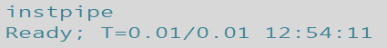
   7. Decode, unpack, and write the files needed to run DVDPRIME to the 2222 minidisk.
      1. pipe dvddecod *ddd*222 image w |UNPACK| *restcmnd* 2222  
         pipe dvddecod CKD222 image w |UNPACK| ECKDREST 2222  
         
         1. *ddd***CKD** for **3390** or FBA for FBA (SCSI). This value must be entered in uppercase.  
            *restcmnd***ECKDREST** for **3390** or MDREST for FBA (SCSI).
   8. Access install user’s 2222 mdisk as C and Run DVDPRIME.
      1. Access mdisk filemode  
         Access 2222 c  
         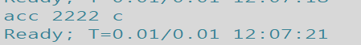
      2. Access mdisk filemode  
         Access 191 a  
         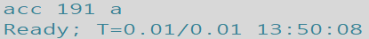
      3. Dvdprime DASDtype (operand  
         Dvdprime 3390 (disk  
         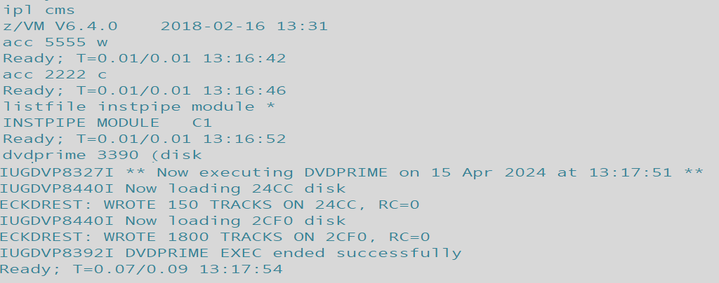

1. Verify access to mdisk 4CC is established (24CC for 2nd Levels) and run, “**Instplan** *traditional”* to begin Installation Wizard and begin filling panels in accordance with Installation Worksheets.
   1. **Query** *device* *filemode***Q** *disk C*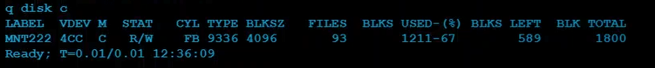
   2. **Instplan** operand**instplan** traditional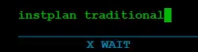(Installation Wizard Panels will open)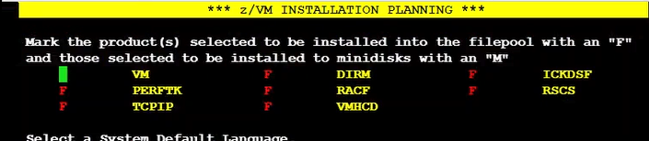

1. Fillpanels with information established and recorded on Installation Worksheets.  
     
   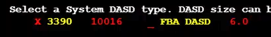
   1. Place X’s on spaces to make selections, Function keys to receive help, quit or submit.
      1. Note: Very important to take note of any values input that aren’t present on Worksheets for posterity.  
         Ex. Did you load DIRM onto a Minidisk (M) or SFS File System (F)? Different password, new name, etc.
      2. For Format selection choose No if volumes are already CP formatted. Selecting no will still Label the volumes. ‘N’ was chosen in this example.
   2. Answer **Y** when asked whether to continue after selection of Cluster name and submission. Which will reopen the Installation Wizard.  
      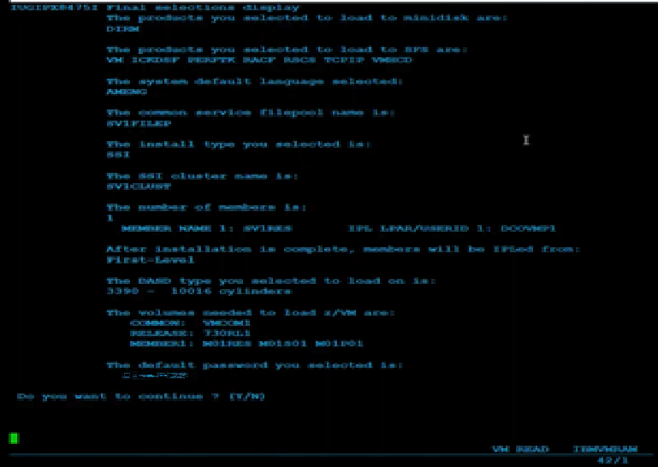
   3. Fill in the new Panels and Submit (F5)
   4. The SSI Cluster is then IPLed. Confirm the output messages match what you have marked down for your Installation Worksheets.  
      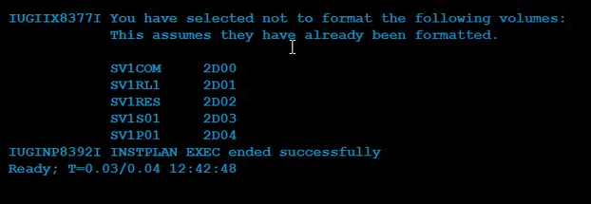

1. Attach any unattached volumes (DASD) used/listed on your installation worksheets that are not already attached and run **INSTALL** to install the newly loaded and specified system.
   1. **Query** operand**q dasd**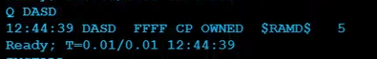(None of the DASD used in the Install are attached yet as shown above.)
   2. **Attach** *dasdaddr target***Att** *2d00-2d04* *  
      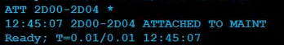
   3. **Install**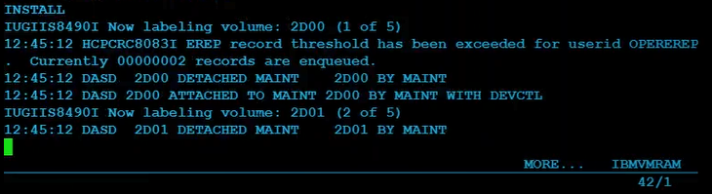(A large number of messages will scroll past the screen as shown below.)  
      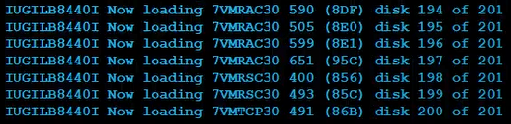
   4. After the two maint disks Load; system will establish values, create connections, attach devices, and generate files etc. - navigate the message scrolling with the Clear key. The system will shut down and REIPL, beginning more setup tasks, finally asking the user to **press** <*ENTER*>.

1. **Press** <*ENTER*> key to continue from system IPL/Load output messages and Login-Screen then log in with MAINTvrm
   * 1. (Maintvrm = Maint version release modification = maintenance user + zVM version 7.3 = MAINT730)
   1. **Press** *<ENTER>* key  
      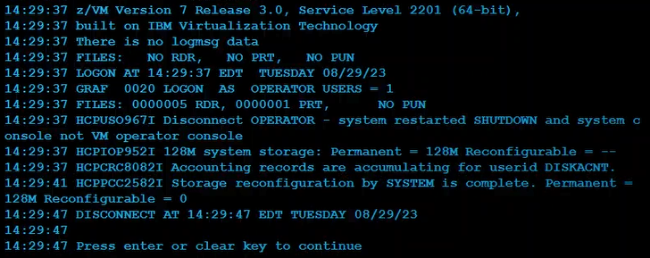
      1. If logged in as Operator (MAY be auto-disconnected to the login screen, if not :) use the disconnect command and log into MAINTvrm.  
         #cp disconnect  
         #cp disc
   2. **Log** **in**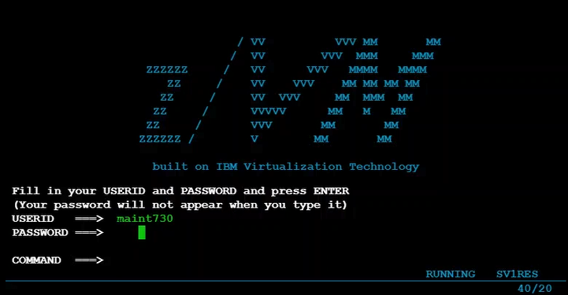

1. In order to IPL the system again beyond the IPL at System installation, from the first level host system submit an IPL command from the user that will host the 2nd level system.
   1. Ex.  
      IPL vdev  
      IPL 705D
      1. TCPIP will need to be installed before running remotely from a disconnected user.
         1. After installing TCPIP to IPL a second level system submit xautolog and FOR commands from another privileged user.
            1. Xautolog install-user  
               Xautolog inst640
            2. FOR user CMD command operand  
               For inst640 cmd set run on
            3. FOR user CMD command operand  
               For inst640 cmd term conmode 3270
            4. For user CMD command operand  
               For user CMD IPL 705D

(a), (b), (c), (d) together subsequently will log the user on, set its running parameters for hosting the system, then IPL the system via the RES volume on the specified DASD.

Return to Overview of System Installation Second Level (top)

*Return to System Installation Second Level Method*

Creating a New User



1. Request a copy of the disk map to identify GAP’s in available storage via :
   1. Dirm Dirmap  
        
      
   2. Obtain the Directory map file via :
      1. Receive spoolid (rep  
         Receive 41 (replace  
         
         1. Rep option replaces any current same name file
   3. Identify the region used for user storage (typically rows of Name 191) and find a gap of 100 or more taking note of the cylinder the starts the gap:  
      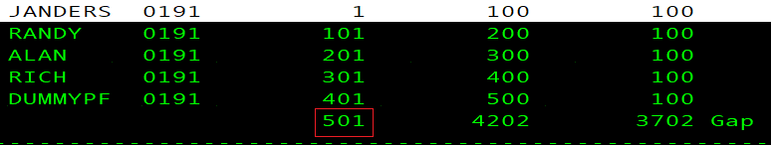
      1. The gap-start cylinder will be the number used to edit the MDISK statement for the new user’s (In this example the gap begins on 501)
2. Acquire copy of USER Direct CMS file to act as template.
   1. Dirm for user get  
      
      1. Should the file be locked already submit an unlock then repeat step 2)a)  
         Dirm for user unlock  
         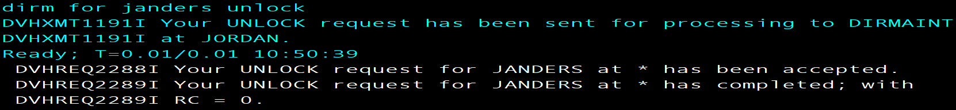
   2. Obtain the Direct file via :
      1. Receive spoolid (rep  
         
         1. Rep option replaces any current same name file
3. Xedit the Direct file to match the new user’s desired login, storage, and access information
   1. Xedit fn ft fm  
      xedit dummypf direct a  
        
      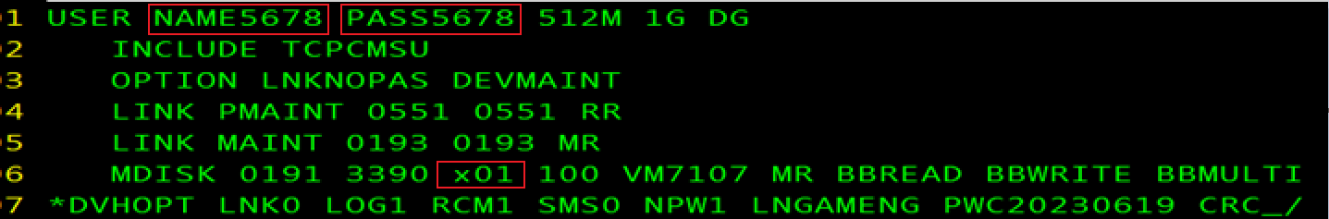
      * 1. Edit username and password
        2. Include TCPCMSU (this profile contains shared links and basic console statements)
        3. Nopass Option for utility drives (ex. MAINT/DEVMAINT/PMAINT)
        4. Link and MDISK statements to access tools and your personal storage (191 A)
           1. Be sure to write the correct starting cylinder((x01 in red box above) Step 1-c’s image shows the example gap in red box)
        5. POSIXINFO UID and GID if intended to use BFS
   2. Type FILE in the command line to save the file.
4. Put on Judas Priest's Screaming For Vengeance.
   1. Turn it up to 11.  
      
5. Request, acquire and update the authfor control file. (This enables commands, do so only for known admins.)
   1. Dirm send authfor control  
      
      1. Add copies of the 150 and 140A lines for User – Matching others in file
   2. Receive spoolid option  
      Receive 105 (replace  
      
   3. Dirm file authfor control  
      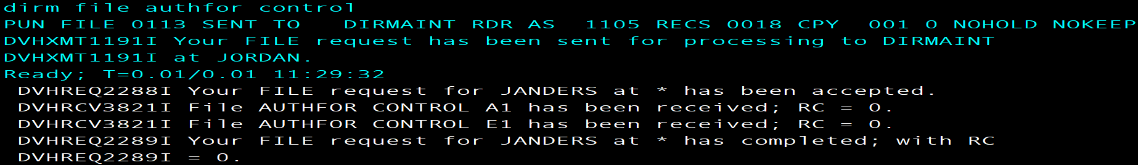
      1. This submits changes made to the Authfor file
6. Add the user’s name to the system :
   1. Dirm add user  
      DIRM add Rich  
      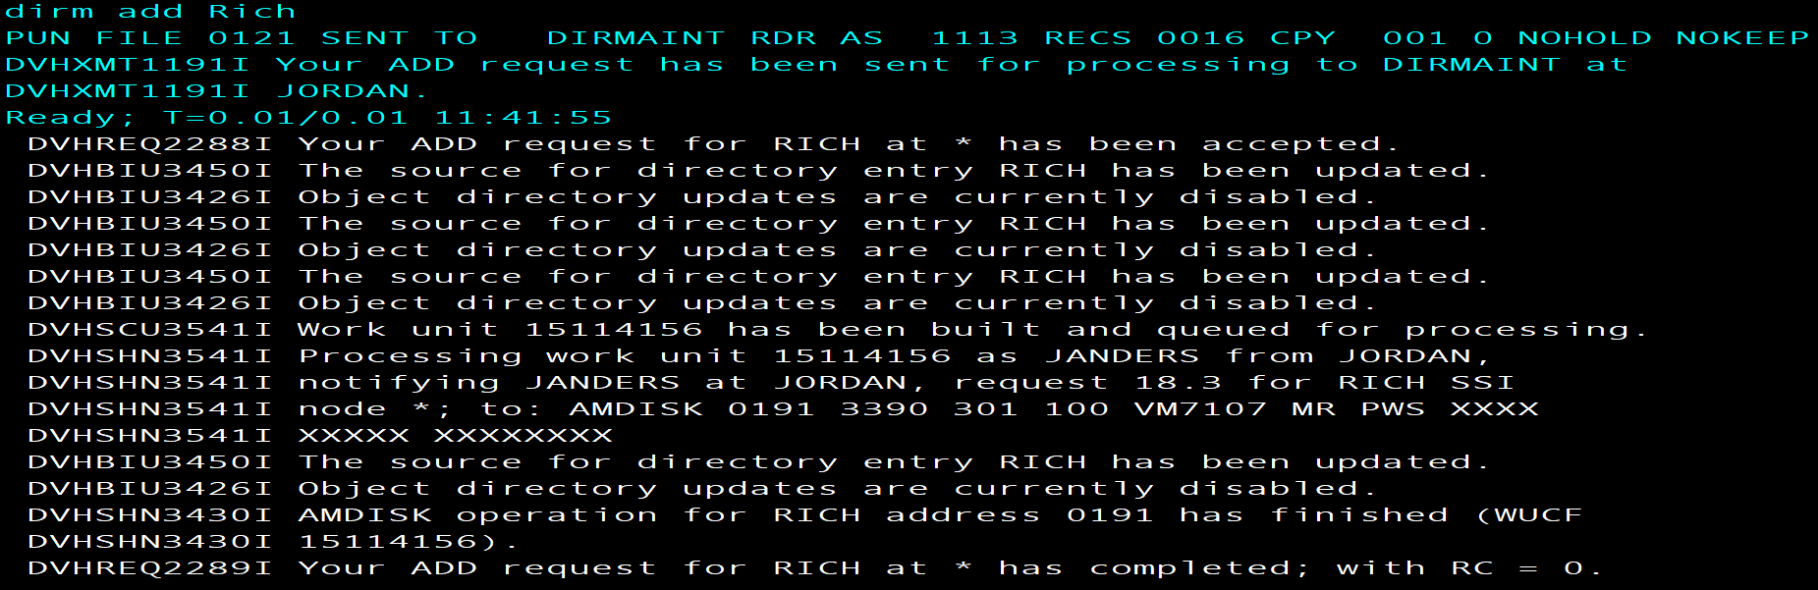
7. Check the newest USER MDISKMAP to make sure there are no Overlaps.
   1. Use the slash character and user name to Xedit search the DISKMAP:
      1. /username
8. Logon to the new user and FORMAT 191 A
   1. FORMAT vdev filemode  
      FORMAT 191 A  
      
      1. Answer 1 for Yes  
         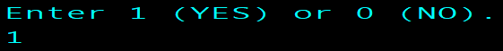
      2. Give minidisk unique name (typically three letters three numbers)  
         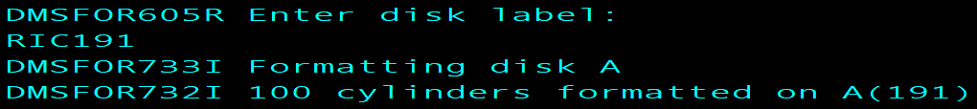
9. VMLINK to another user to get the needed setup/reference files:
   1. Vmlink user 191  
      VMLINK Rich 191  
      
      1. profile exec
      2. syn synonym
      3. profile xedit  
         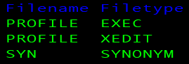
   2. Acquire the files using copyfile or sendfile them from another user to new user
      1. Copyfile fn ft fm Newfn Newft Newfm  
           
         or
      2. Sendfile fn ft fm to user
   3. Pull down the copies
      1. Receive spoolid (options  
         receive 105 (replace  
         
10. If any additional changes were made after, “DIRM add name” (step 6-a) send the new Direct file to DIRMAINT (Or update the directory/bring changes online)
    1. DIRM for user options  
       Dirm for Janders replace   
       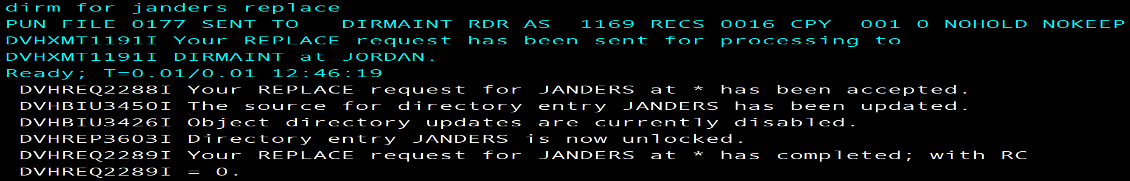
       1. If the file is unlocked and requires a lock for replacement input the following and repeat 10-a.
          1. Dirm for user options  
             DIRM for Janders lock  
             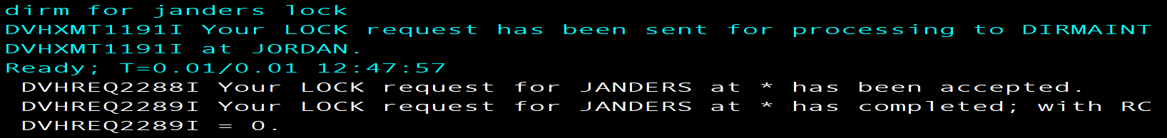  
             Return to Step1 of System Installation Second Level Method

***Return to System Installation Second Level Method*FTP Method**

**Using a z/VM FTP server to receive and load files to a z/VM minidisk (zVM 7.3 Installation Guide.pdf, Appendix K.)**

The following procedure will receive and load the z/VM product DVDs or electronic envelopes to a minidisk on your z/VM system. If loading the files from the electronic envelopes to a directory on your workstation, make a note of the directory path name. Make sure the minidisk where you will load the files is not attached in write mode by any user ID on z/VM. You must have an FTP server running on the z/VM system and a user ID on z/VM that owns an 8000- cylinder minidisk. The minidisk should be formatted with 4K blocks. The user ID should be logged off while you are loading the installation files. To begin open a DOS window on your work station (Like CMD Command Prompt).

**Note**: For this example, the user ID used was JORDAN and the minidisk is 191 and the files were stored on a windows desktop folder named zPROTempBox.  
  
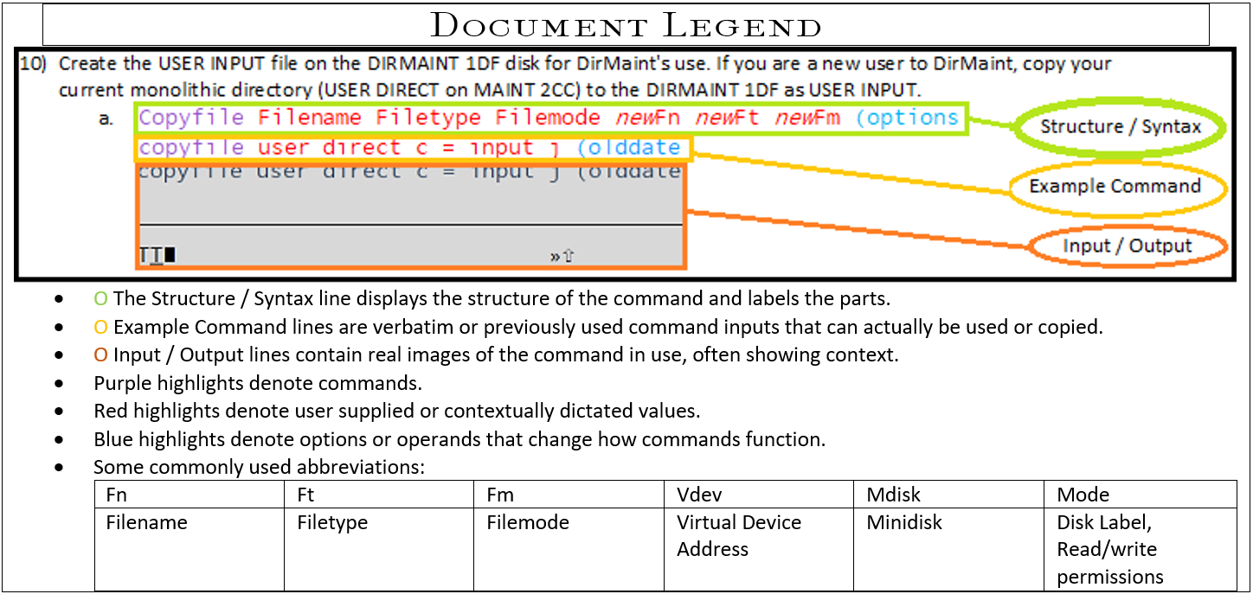

1. Start the FTP session with your z/VM host replacing the x placeholder with the appropriate IP:
   1. ftp *options ipaddress*  
      ftp -i *xx.x.xx.xxx*  
      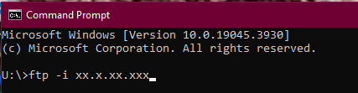
2. Enter the z/VM user ID that can access the minidisk in write mode and the password for that ID:
   1. Username  
      JORDAN  
      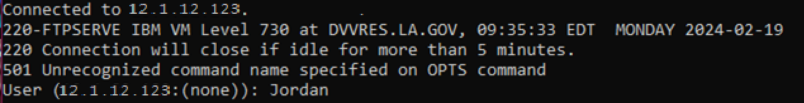
   2. password  
      xxxxxxx  
      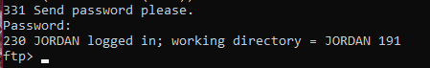
3. Change the working directory on your z/VM host to the minidisk where you want to load the files (note that there is a period between the user ID and minidisk address):
   1. cd zVMdirectorypath  
      cd JORDAN.191  
      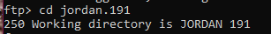
4. Set the Local Directory to the Windows Desktop folder location containing the files you intend to FTP or the destination folder for the files you’re FTPing from zVM.
   1. lcd desktopfolderpath  
      lcd C:\Users\P00341017\Desktop\zPROTempBox  
      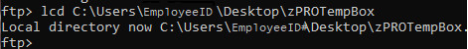
5. Set the file transfer mode to binary and the record format and length to fixed 1028:
   1. binary  
      binary  
      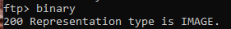
6. Set the file transfer size to 1028 bytes. (Logical Record Length, AKA Lrecl)
   1. quote site fixrec recordlength  
      quote site fixrec 1028  
      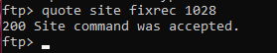
7. Put the installation files on the z/VM minidisk:
   1. mput file  
      mput *.PROD5*  
      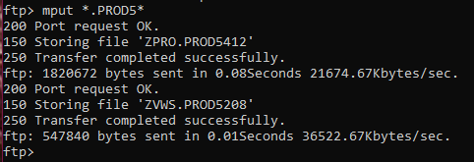
   2. All of the files in the directory that contain, “.PROD5”will now start to transfer. This could take some time, depending on the speed of your connection. For video walkthrough see, “zVM 7.3 FTP” within Reference Materials>Examples>FTP.

*Return to Step2*

Install_zVM

Install_DIRM  
Install Dirmaint



1. Log on to the MAINT730 user.
2. Set DirMaint to the enabled state.
   1. Service dirm operand  
      service dirm enable  
      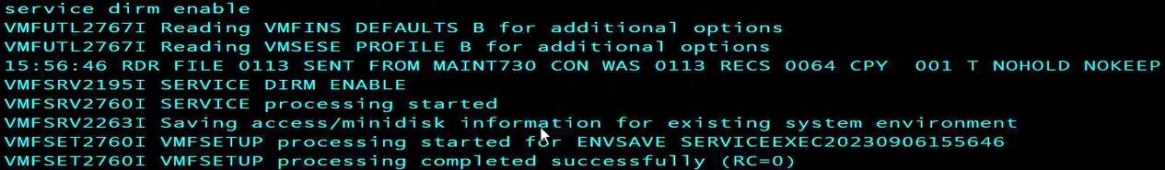
3. Create the LNKACCSS and CPYFRPLC executables using Xedit. Copy and paste the contents of the respective example files linked in this document to generate a useable executable which can be invoked by inputting the name in the command line with access.
   1. XEDIT *fn ft fm*  
      XEDIT *LNKACCSS EXEC A*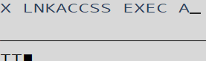
      1. Add *#*  
         Add 22  
         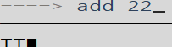

* + 1. LNKACCSS EXEC
  1. XEDIT *fn ft fm*  
     XEDIT *CPYFRPLC EXEC A*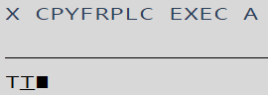
     1. Add *#*  
        Add 24  
        

* + 1. CPYFRPLC EXEC

1. Run LNKACCSS EXEC (Script Contents can be pasted into a new Xedit document, fn LNKACCSS ft EXEC)
   1. LNKACCSS filetype filemode  
      LNKACCSS EXEC A  
      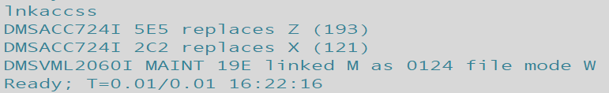
   2. Check the mdisk filemodes have been accessed with a query disk.  
      Query Operand  
      Query Disk  
      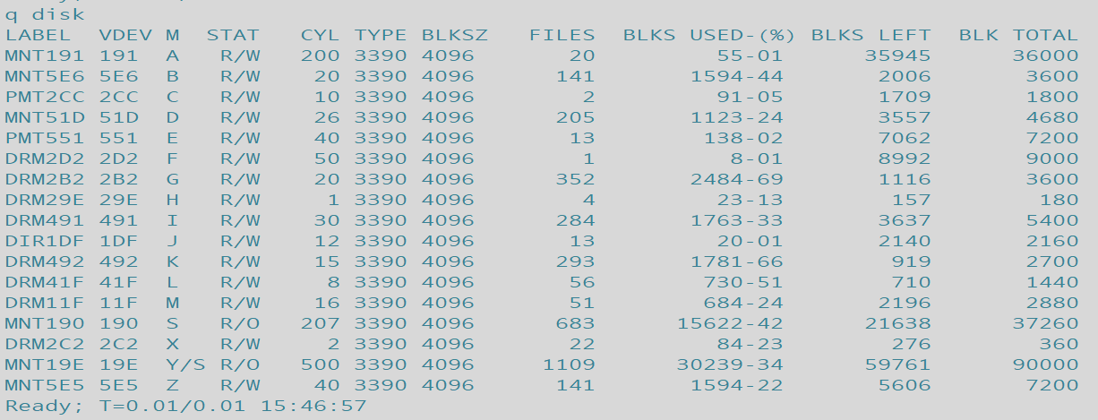

1. Create a product parameter override file (PPF) with XEDIT to set DIRMAINT’s runmode to operational. The override file for DIRM will have a filename of CONFIGxx (example CONFIG99) where x is a user selected value for identification and a filetype of DATADVH. Files are used in reverse alphabetical. Thus Config99 will run before ConfigAA Copy or save this file to the DIRMAINT 41F mdisk. Create Authfor Control with Xedit in the same manner.
   1. XEDIT *fn ft fm*  
      XEDIT *CONFIGxx DATADVH A*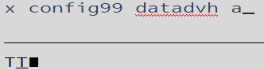
      1. Add *#*  
         Add 3  
         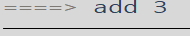
      2. Edit the new lines as shown below.  
         CONFIG99  
         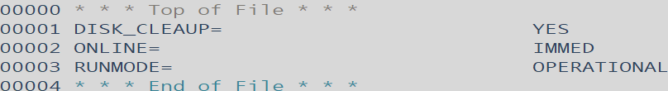
      3. Use File to save your changes.  
         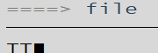
   2. Create the Authfor Control (<-example/contents hyperlinked) file and save it to your A disk for transfer at a later step. You will need to have an accessible user (typically Maint730 first) in order to perform administrative tasks once DIRM is set up.  
      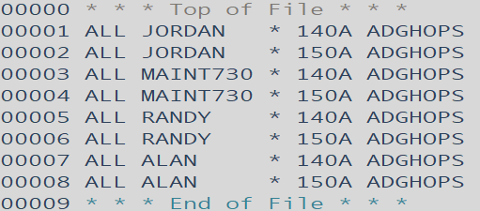
      1. XEDIT *fn ft fm*XEDIT *Authfor Control A*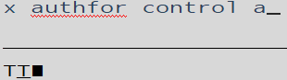
      2. Add #  
         add 8  
         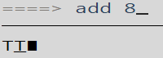
2. Generate, rename and relocate files on the DIRMAINT file list. To do this either:
   1. Run the CPYFRPLC EXEC.  
      CPYFRPLC EXEC A  
      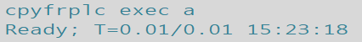
      1. ALTERNATIVELY: Gain write access to the listed mdisks on the left with link or vmlink with a *write option* then use the copyfile command to rename and relocate the file to the location on the 🡪 right. (Default location of sample files is 7VMDIR30 2C2.)
      2. Below is a table of the files that must be copied or generated and placed on a specific MDISK.

Filename Filetype Vdev 🡪 Filename Filetype Vdev

N/A N/A Xedit 🡪 Config99 DATADVH 41F  
DVHPROFD SAMPDVH 2C2 🡪 DVHPROFA DIRMAINT 492   
DVHPROFM SAMPDVH 2C2 🡪 DVHPROFM DATADVH 492   
DVHPROFS SAMPDVH 2C2 🡪 DVHPROFA DIRMSAT 492  
N/A N/A Xedit 🡪 AUTHFOR CONTROL 1DF   
EXTENT SAMPDVH 2C2 🡪 EXTENT CONTROL 1DF 🡨 All of these mdisks belong to 7VMDIR30  
LINUX SAMPDVH 2C2 🡪 LINUX PROTODIR 1DF ex. Link 7vmdir30 1df 1df wr  
LINDFLT SAMPDVH 2C2 🡪 LINDFLT DIRECT n/a acc 1df q  
PROFILE EXECSAMP 2C2 🡪 PROFILE EXEC 491 OR  
140CMDS SAMPDVH 2C2 🡪 140CMDS DATADVH 41F ex. Vmlink 7VMDIR30 41F (write  
150CMDS SAMPDVH 2C2 🡪 150CMDS DATADVH 41F   
ACCESS SAMPDVH 2C2 🡪 ACCESS SAMPDVH MAINT 19E  
AUTHDASD SAMPDVH 2C2 🡪 AUTHDASD DATADVH 492   
CMS SAMPDVH 2C2 🡪 CMS PROTODIR 1DF  
CMSDFLT SAMPDVH 2C2 🡪 CMSDFLT DIRECT N/A   
CONFIG SAMPDVH 2C2 🡪 CONFIG DATADVH 41F  
CONFIGRC SAMPDVH 2C2 🡪 CONFIGRC DATADVH 41F *ConfigRC is for RACF, use only for RACF  
DATAMOVE SAMPDVH 2C2 🡪 DATAMOVE DATADVH 492   
DIRMAINT SAMPDVH 2C2 🡪 DIRMAINT DATADVH 492  
DIRMMAIL SAMPDVH 2C2 🡪 DIRMMAIL NEWMAIL 41F   
DIRMSAPI EXECSAMP 2C2 🡪 DIRMSAPI EXEC 41F  
DIRMSAT SAMPDVH 2C2 🡪 DIRMSAT DATADVH 492   
DVHNAMES SAMPDVH 2C2 🡪 DVHNAMES DATADVH 492

* + NOTE: These files may already be present, relocated and renamed- but REPLACE regardless.  
    ORIGINAL LIST HERE.
  1. After moving the files confirm they’ve been properly relocated and renamed by listing the files on the target mdisks: 41F=L, 492=K, 491=i, 1DF=J
     1. Filelist *fn* *ft* *fm*  
        Filel *\* * W*  
        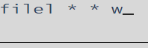
        1. The * symbol here is a wildcard. In this case it lists any filetype and name in mdisk(fm) W.

1. Run PUT2PROD to place any outstanding DirMaint service, such as a previously applied RSU, into production. Create the Authfor Control file which will act as the keyring for access to DIRMAINT commands. Copy the Authfor Control file to 7VMDIR30 41F mdisk.

* Important: If you are running in an SSI cluster you need to run PUT2PROD on every member before continuing with rest of these instructions. You need to do this as this is how DirMaint gets enabled on the other members.
  1. put2prod dirm  
     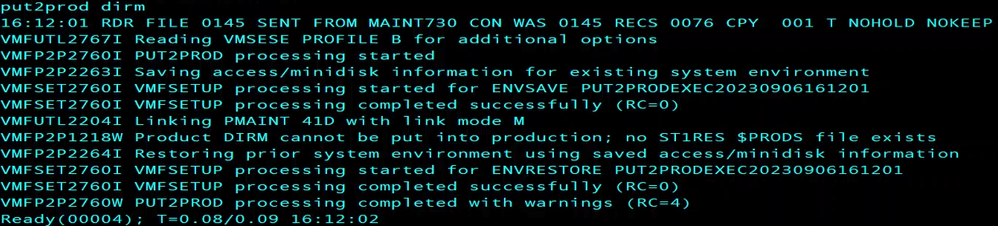

1. Overwrite DIRMAINT, DATAMOVE, and DIRMSAT user ID's Passwords. VMLINK to 2CC and change the passwords of these DIRM user ID’s to the default (Chosen at installation.) Leave any DATAMOV# or DIRMSAT# ID’s passwords unless in a cluster. Last, update and bring these changes online with directxa.
   1. Xedit *fn ft fm*Xedit *User Direct C  
      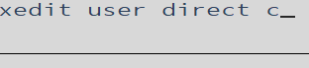*
   2. Operand */searchterm  
      /r dirmaint  
      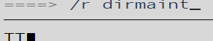*  finds 🡪 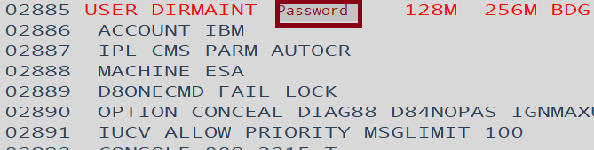
      1. Type the desired password *over* the old password.
   3. On the XEDITOR ====> command line use the FILE command to save changes to the file after overwriting the passwords.  
      FILE  
      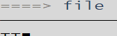
   4. Submit the changes and create the directory.  
      DIRECTXA  
      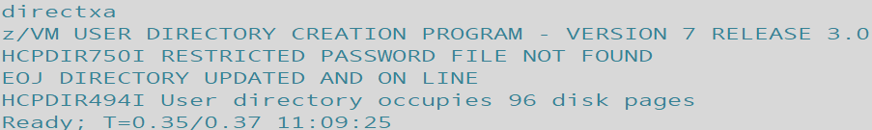
2. Access the disk where the DIR2PROD EXEC resides as well as certain DirMaint server and 7VMDIR30 test build minidisks which contain your production tailorable system files using the DIR2PROD exec. Use LINK and ACCESS commands to assign appropriate file modes and gain access. Confirm mdisk access and filemodes match with query.
   * 1. Running the script may not be necessary but confirms the correct filemodes.
   1. dir2prod access_new *7VMDIR30* DIRM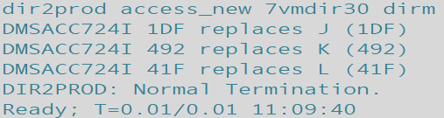
      1. Use DIRM if installing to minidisks or DIRMSFS if installing to SFS. In this example DIRM is used.
      2. Any missed mdisk access will be called out by the system, simply make the link and access it or correct the filemode as requested:  
         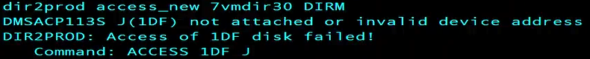
3. Create the USER INPUT file on the DIRMAINT 1DF disk for DirMaint's use. If you are a new user to DirMaint, copy your current monolithic directory (USER DIRECT on MAINT 2CC) to the DIRMAINT 1DF as USER INPUT.
   1. Copyfile Filename Filetype Filemode *new*Fn *new*Ft *new*Fm (options  
      copyfile user direct c = input j (olddate  
      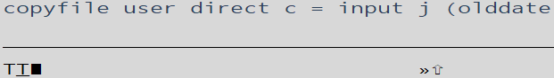
      1. The directory is monolithic when all the user information is in one file i.e. the User Withpass file. Rather than a list of specific lines of information like the user direct file created by directxa.
4. Query whether any of the DirMaint server machines, DIRMAINT, DATAMOVE, or DIRMSAT, are logged on, you need to log them off. Access the disk where the DIR2PROD EXEC resides, 7VMDIR30 492 as E. Copy code from the test minidisks to the production minidisks. If you are running in an SSI cluster you need to log onto each member of the cluster and run this command as it updates the MAINT 19E disk.
   1. Query operand  
      Q name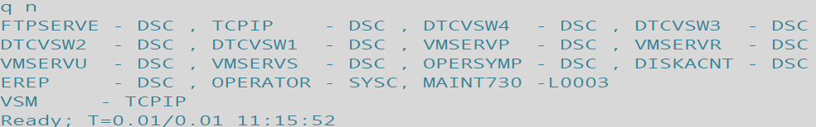
   2. Dir2prod operand user type  
      dir2prod update_files *7VMDIR30* DIRM  
      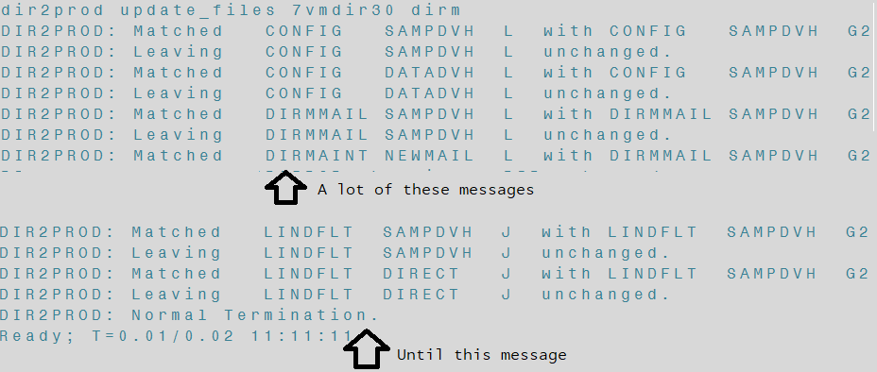
   3. Instruct DIRMAINT to place user tailored files into production. (Most mdisk’s for dirmaint have a front and back end version- one that is in active use/ can be used to place edited files, and the file set DIRMAINT uses as a record and for placing things into production.)
      1. Dir2prod operand user type  
         dir2prod prod *7VMDIR30* DIRM  
         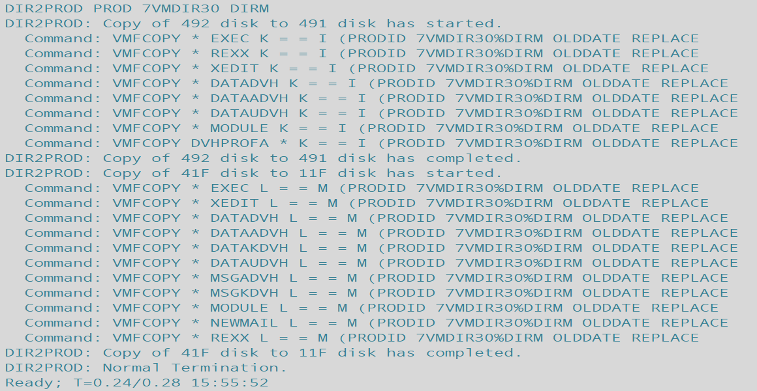
5. Logon to the DIRMAINT server. Verify it is working. It should prompt the user to start work by inputting, “DVHBEGIN”
   1. Dvhbegin  
      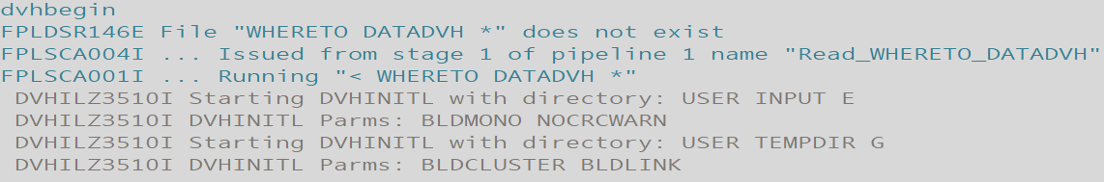
      1. After DIRMAINT finishes initializing and setting up, output should display as such:  
         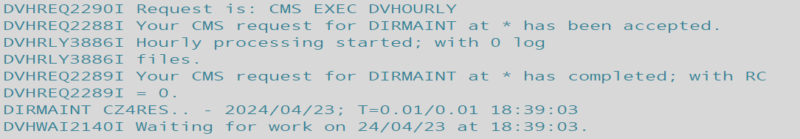
   2. IF DIRMAINT DOES NOT initialize properly and does NOT give the waiting for work message time to troubleshoot:  
      
      1. IMPORTANT if you receive, “WHERETO DATADVH not found” it’s because you did not copy the user direct from 2cc to 1df.
      2. Should you receive a DVHNAME message, it is most likely that one or more of the files to be tailored and copied was not properly done.
      3. If DIRMAINT wasn’t running recently or this is the first begin submitted since IPL there may be a flood of messages, “More…” - simply Clear key through them to the end (slowly enough for Reflections to take screengrabs.)
      4. If you see message 'DVHITI3531W An OFFLINE CONTROL exists...’ a file: OFFLINE CONTROL is holding changes.   
         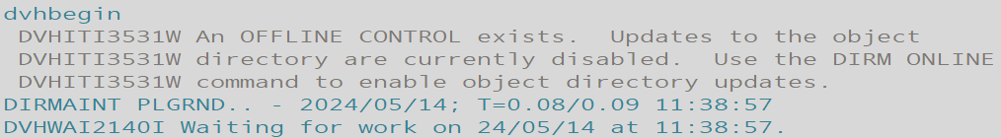
         1. Otherwise you must later issue DIRM ONLINE from an authorized user before automatic object directory updates will occur.
         2. Issue ONLINE if you want to enable object directory updates according to the ONLINE= configuration statement.  
            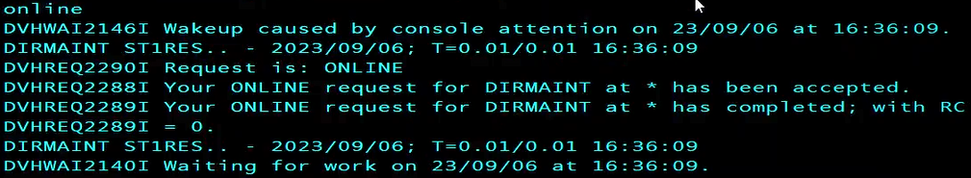
   3. After you see the, “Waiting for work” message then disconnect the server by issuing:  
      #CP DISC  
      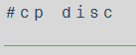
6. Lastly link with the 7vmdir30 (_vmdir__ release specific user) and it’s 41F MDISK with write privileges to disable RACF’s default YES ALL setting within ConfigRC DATADVH by placing a ‘/’ slash in the first column of the statement. (Alternatively you can just delete the file or simply don’t make it/transfer it during this process.)
   1. Form the mdisk link.  
      vmlink user mdisk (options  
      vmlink 7vmdir30 41F (write  
      
   2. Open the ConfigRC Datadvh file in xeditor.  
      xedit filename filetype filemode  
      x configrc datadvh z  
      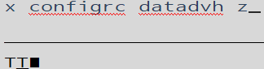
   3. Search for, “YES ALL” or navigate to line 97, which should be the only uncommented statement.  
      /Searchterm  
      /YES ALL  
      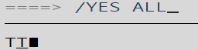
   4. Place a, ‘/’ slash in the first column, effectively disabling the statement and RACF (assuming you do **not** wish to use RACF.)  
      /  
      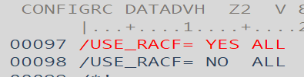
   5. File and save your changes.  
      File  
      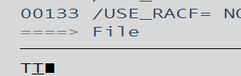
7. Congrats, you now have an immediately online, hourly, daily checking fully functional DIRMAINT installed and in active use!

File Tables:  
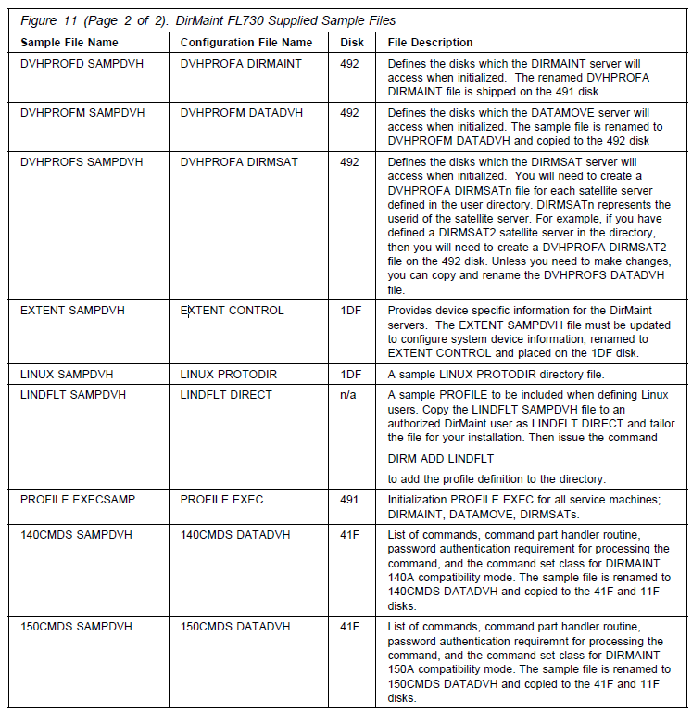  
1 of 2  
  
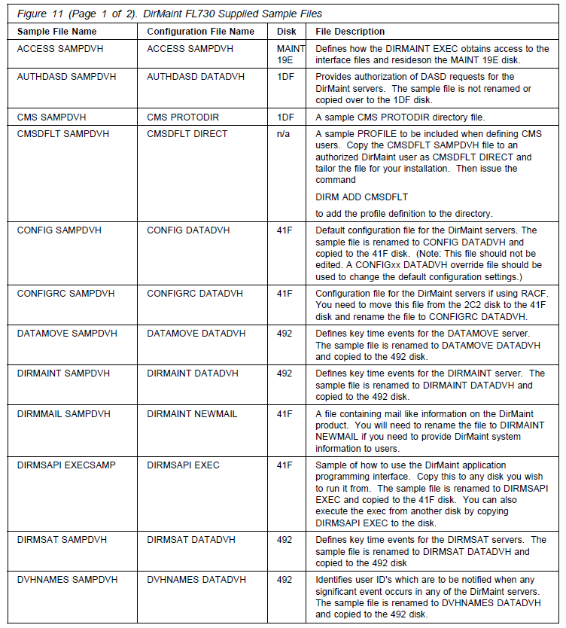  
2 of 2

**Return to current step.**

***LINK AND ACCESS***

LNKACCSS EXEC script:  
  
/* Link and Access for DIRM Install */

'link maint 5e5 5e5 wr'

'acc 5e5 z'

'link 7vmdir30 491 491 wr'

'acc 491 i'

'link 7vmdir30 492 492 wr'

'acc 492 k'

'link 7vmdir30 41f 41f wr'

'acc 41f l'

'link 7vmdir30 2c2 2c2 wr'

'acc 2c2 x'

'link 7vmdir30 2b2 2b2 wr'

'acc 2b2 g'

'link 7vmdir30 2d2 2d2 wr'

'acc 2d2 f'

'link 7vmdir30 29e 29e wr'

'acc 29e h'

'link 7vmdir30 1df 1df wr'

'acc 1df j'

'LINK 7VMDIR30 11F 11F WR'

'ACC 11F M'

'VMLINK MAINT 19E (WRITE'

Return to instruction steps (top)

***USER GENERATED FILES:* Create these in Xedit after establishing Link and Access, read and write permissions.**  
  
Authfor Example:  
ALL JORDAN * 140A ADGHOPS

ALL JORDAN * 150A ADGHOPS

ALL MAINT730 * 140A ADGHOPS

ALL MAINT730 * 150A ADGHOPS

ALL RANDY * 140A ADGHOPS

ALL RANDY * 150A ADGHOPS

ALL ALAN * 140A ADGHOPS

ALL ALAN * 150A ADGHOPS  
  
**Config99 DATADVH** example:  
RUNMODE= OPERATIONAL

ONLINE= IMMED

ONLINE_VIA_DELTA= ON

DISK_CLEANUP= YES

**Copyfile** section**:****CPYFRPLC EXEC:**

/* Copy and Replace Files for DIRM Install */  
‘copyfile config99 datadvh a = = l'

‘copyfile authfor control a = = j (replace’

‘copyfile dvhprofd sampdvh x dvhprofa dirmaint k (replace’

‘copyfile dvhprofm sampdvh x dvhprofm datadvh k (replace’

‘copyfile dvhprofs sampdvh x dvhprofa dirmsat k (replace’

‘copyfile extent sampdvh x extent control j (replace’

‘copyfile linux sampdvh x linux protodir j (replace’

‘copyfile lindflt sampdvh x lindflt direct a’

‘copyfile profile execsamp x profile exec i (replace’

‘copyfile 140cmds sampdvh x 140cmds datadvh l (replace’

‘copyfile 150cmds sampdvh x 150cmds datadvh l (replace’

‘copyfile access sampdvh x access sampdvh w (replace’

‘copyfile authdasd sampdvh x authdasd datadvh k (replace’

‘copyfile cms sampdvh x cms protodir j (replace’

‘copyfile cmsdflt sampdvh x cmsdflt direct a’

‘copyfile config sampdvh x config datadvh l (replace’

/*‘copyfile configrc sampdvh x configrc datadvh l (replace’ */

‘copyfile datamove sampdvh x datamove datadvh k (replace’

‘copyfile dirmaint sampdvh x dirmaint datadvh k (replace’

‘copyfile dirmmail sampdvh x dirmmail newmail l (replace’

‘copyfile dirmsapi execsamp x dirmsapi exec l (replace’

‘copyfile dirmsat sampdvh x dirmsat datadvh k (replace’

‘copyfile dvhnames sampdvh x dvhnames datadvh k (replace’

Return to instructions Return to Top of Doc

Install_TCPIP

Install TCPIP



1. Fill out a set of configuration worksheets for each member on which you will create a minimal TCP/IP configuration. Configuration worksheets can be found in Appendix L, “Basic TCP/IP connectivity worksheets,” on page 285.
   1. **Note:** You can use the QUERY CHPIDS command to verify the CHPID associated with your network interface device.
2. Log on to the system as MAINT730.
   1. logonmaint730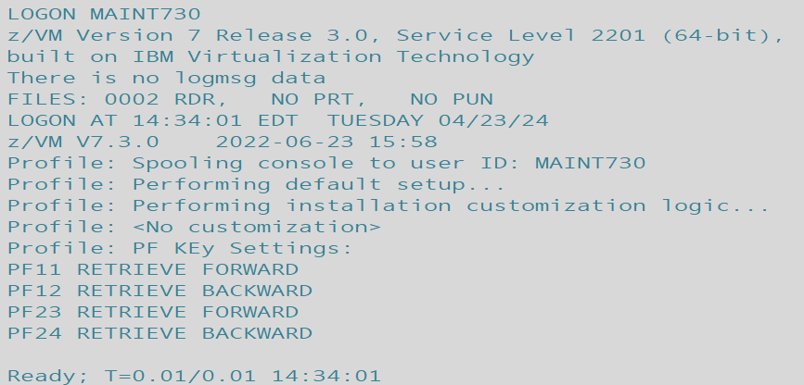
3. Access the minidisk 193 as file mode E.
   1. Vmlink user mdisk  
      vmlink maint 193  
      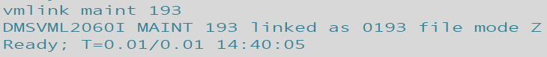
4. Run IPWIZARD.
   1. Ipwizard
5. Using the information you gathered in the TCP/IP configuration worksheets (in Appendix L, “Basic TCP/IP connectivity worksheets,” on page 285), fill in the z/VM TCP/IP Configuration Wizard panel and press F8 to continue.  
   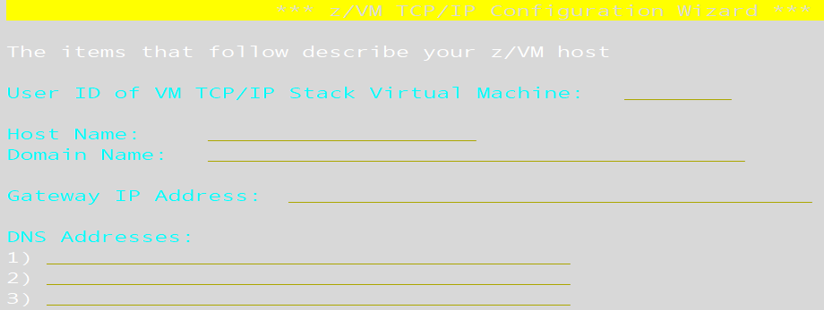
6. Fill in the General Interface Configuration Panel and press F8 to continue. The panel content will depend on whether IPv4 or IPv6 is to be used.
7. Fill in the Interface Configuration Panel and press F5 to process. The panel content will depend on which interface type is to be used.
   1. IPWIZARD attempts to create the TCP/IP configuration files. If the TCPIP user ID is logged on, IPWIZARD asks if you want to restart TCP/IP and continue processing:   
      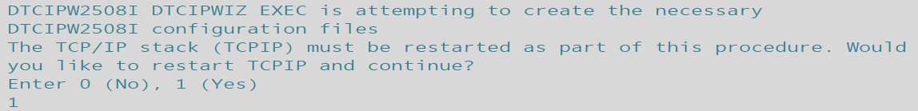
      1. If you continue, IPWIZARD tests the information you provided and returns any errors that occurred. If no errors are encountered, TCP/IP configuration files containing the network information you provided are created. For additional information on configuring TCP/IP, see *z/VM: TCP/IP Planning and Customization*.
   2. Once the pings are attempted if any are missed you’ll be prompted to reattempt. Type 1 to reattempt and standby for output on success or failure.  
      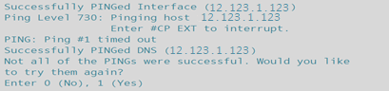
      1. After answering yes, successful output should appear as below:  
         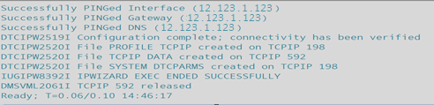
8. The PROFILE EXEC on the AUTOLOG1 191 minidisk contains a commented-out XAUTOLOG statement for TCPIP. Removing the comment characters around the statement will autolog the TCPIP server during CP IPL.
   1. Gain access to the Autolog1 user’s 191 MDISK, Autolog1 191 to open the Profile Exec file and edit it.  
      vmlink user mdisk (options  
      vmlink autolog1 191 (write  
      
   2. Open the PROFILE EXEC in Xedit.  
      Xedit filename filetype filemode  
      Xedit Profile Exec X  
      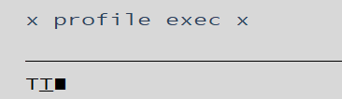
   3. Remove the comment characters from this line:  
      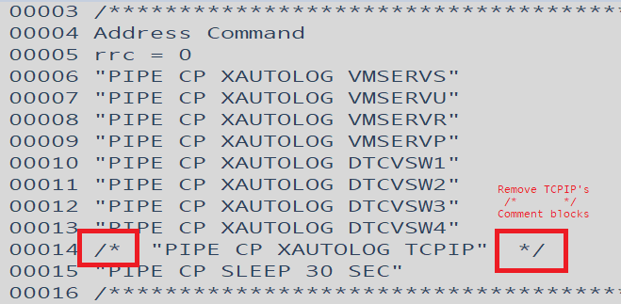
      1. After removal the line should look like so:  
         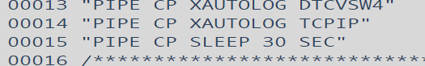
   4. Then save changes with the FILE command.  
      file  
      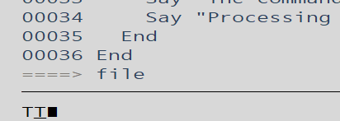
9. If you have a multimember SSI cluster, log on as MAINT730 on each member and repeat substeps “3” on page 92 through “9” on page 93 to configure a basic IP network connection for each member, using the corresponding tables from Appendix L, “Basic TCP/IP connectivity worksheets,” on page 285.



Return to TCPIPStep1

Install_TCPIP

Install_FTP

Install FTP

1. Log into a privileged user (one listed in the AUTHFOR CONTROL file) and establish access and write privileges to: TCPMAINT 198, 591 and 592. TCPMAINT 198 will be where the files being worked on will be filed/saved.  
   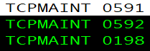
   1. Link ownerid mdisk *new*mdisk filemode  
      Link TCPMAINT 198 198 MR  
      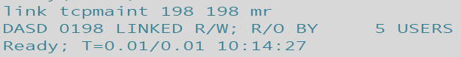
   2. Access mdisk filemode  
      Access 198 z  
      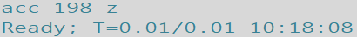
   3. Link ownerid mdisk *new*mdisk filemode  
      Link TCPMAINT 591 591 WR  
      
   4. Access mdisk filemode  
      ACC 591 X  
      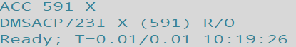
   5. Link ownerid mdisk *new*mdisk filemode  
      Link TCPMAINT 592 592 WR  
      
   6. Access mdisk filemode  
      ACC 592 W  
      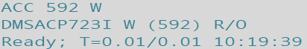
      1. Write access is only necessary for TCPMAINT 198 so the user may overwrite/save to it.
      2. TCPMAINT 591 and 592 need to be linked in order to utilize the SRVRFTP command.
   7. Confirm matching filemodes for consistent example commands:  
      Query Operand  
      Q Disk  
      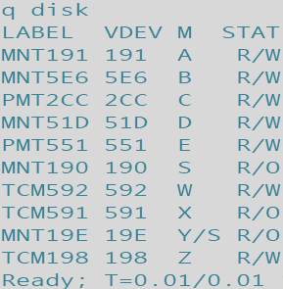
2. Pull down a copy of SRVRFTP SCONFIG for customization/editing.
   1. Copyfile FileName FileType FileMode newFN newFT newFM (options  
      COPYFILE SRVRFTP SCONFIG X = CONFIG Z  
      
3. XEdit the SRVRFTP CONFIG file, removing semicolons on desired option blocks for desired options.
   1. Xedit filename filetype filemode  
      x srvrftp config z  
      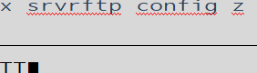
   2. Remove ; semicolon markers from the left-hand margin as shown below for desired options and or modify the statement according to its description block- these blocks have had their semicolons removed in the author’s example system:  
      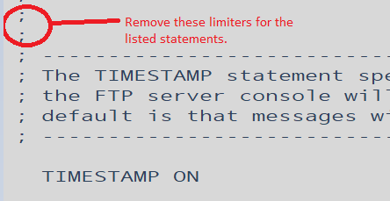

SYSTEMGREETING ON  
TRACE  
PORT 21  
PASSIVEPORTRANGE 20 21  
DONTREDIRECT  
INACTIVE 300  
SECURECONTROL NEVER  
SECUREDATA NEVER  
FTPKEEPALIVE OFF  
AUTOTRANS OFF  
LISTFORMAT VM  
TIMESTAMP ON

(Research and select the features that match **YOUR** environment.)

* 1. Save your changes by typing FILE into the xeditor command line.  
     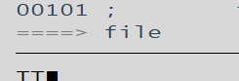

1. Remove comment markers from within TCPIP file, and add Autolog block.
   1. Xedit filename filetype filemode  
      X PROFILE TCPIP Z  
      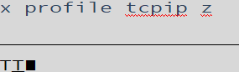
   2. Remove markers (Semicolons ;) by selecting the space they occupy and pressing <Spacebar> to overwrite the semicolon with an open space.  
      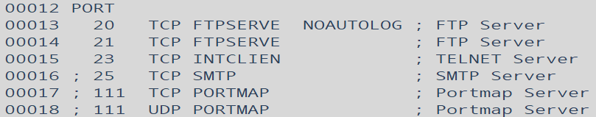
   3. If you’d like FTP enabled on IPL, add AUTOLOG block to the file, select line 7’s margin by <Clicking> the left-hand yellow text 00007 and pressing <F2> three times to add three lines then type the text shown in the red box below, respecting syntax (Spacing, line location, caps.)  
      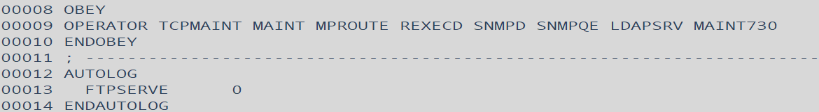
   4. File your changes by typing FILE into the xeditor command line.  
      
2. Run the srvrftp command.
   1. Srvrftp filename filetype filemode (options  
      SRVRFTP SRVRFTP CONFIG Z  
      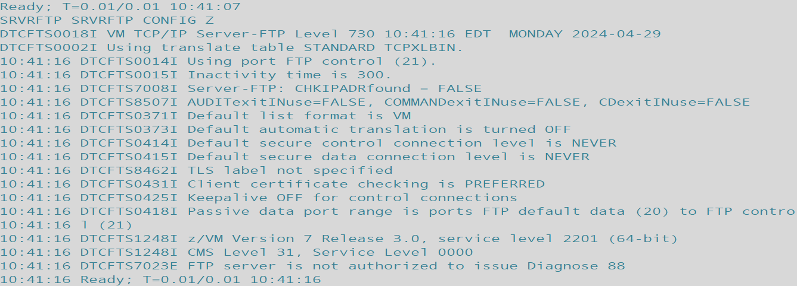
3. Command dirmaint to reload its resident operating procedures (dirm rldcode.) This should allow for autolog to bring ftpserve online disconnected.
   1. DIRM OPERAND  
      DIRM RLDC
4. Ask autolog to log FTPSERVE online disconnected to enable FTP connectivity.
   1. XAUTOLOG USERID PARAMETERS  
      XAUTOLOG FTPSERVE
5. **(***Only necessary if FTPSERVE won’t autolog and DIRM RLDC didn’t work***)** Shutdown and REIPL the system.
   1. SHUTDOWN operands  
      SHUTDOWN REIPL  
      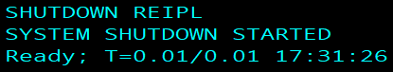

Install_FTP

Make_a_copy

VMLINK Example



1. Establish the virtual link and if necessary use an option for write privileges.
   1. VMLINK user mdisk (option  
      vmlink pmaint cf0  
      
      1. For write privileges specify write as the option.  
         VMLINK user mdisk (option   
         vmlink pmaint cf0 (write
2. Copy the file renaming it or changing the filetype and specifying the filemode for the disk that the user would like the file saved to. The first set of Filename, Filetype, Filemode are for the target file and the second set of fn ft and fm set the new copies file settings.
   1. Copyfile filename filetype filemode filetype filename filemode  
      copyfile system config z = = a  
      

System_config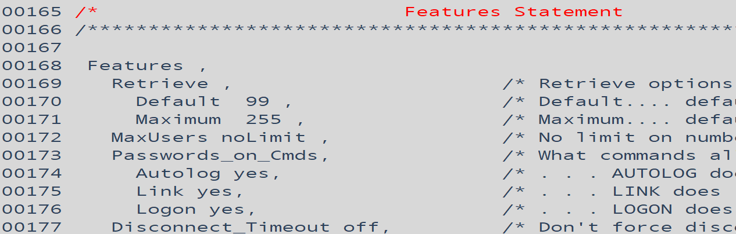

Extent_control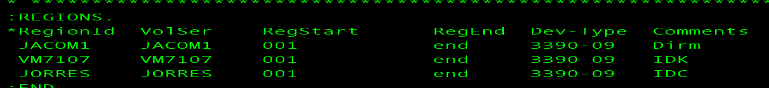

Authfor_Control  
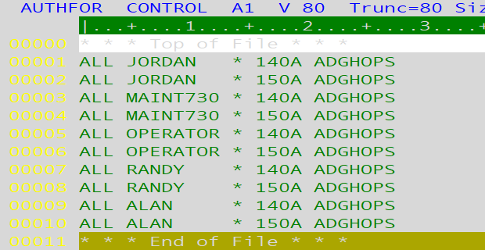

TCPIP_profile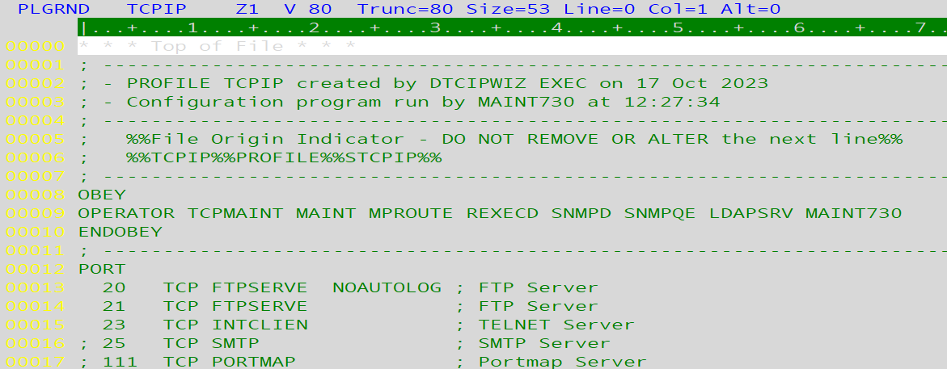

Device_Ranges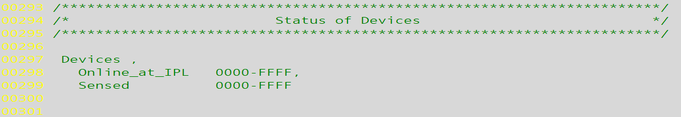

Features_Statements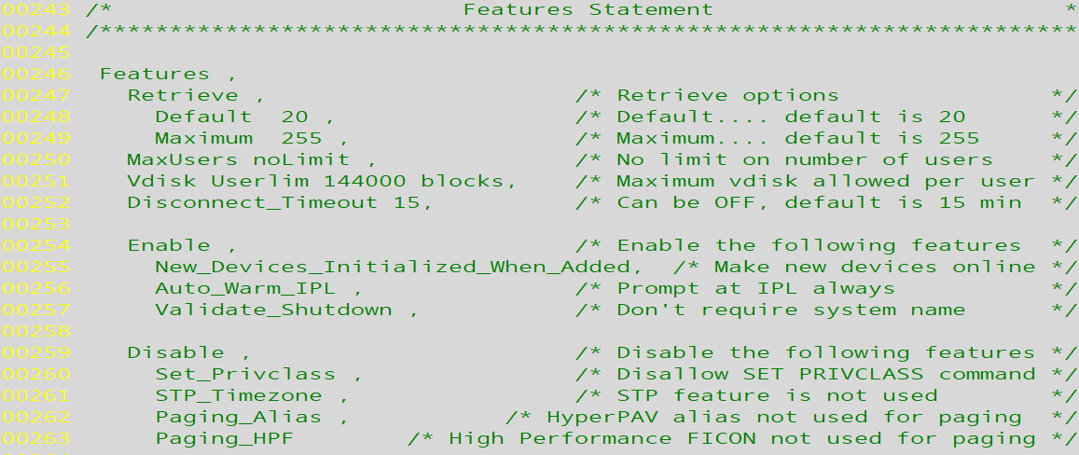

Timezones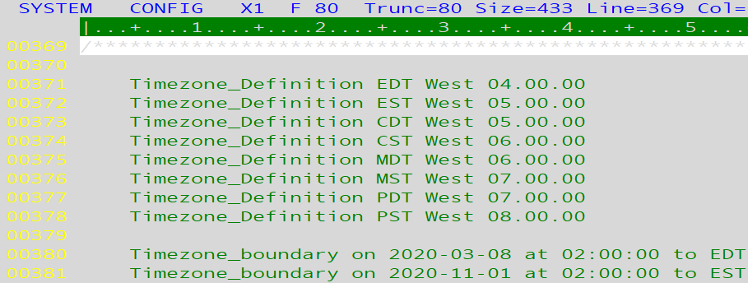

User_Volume_Statements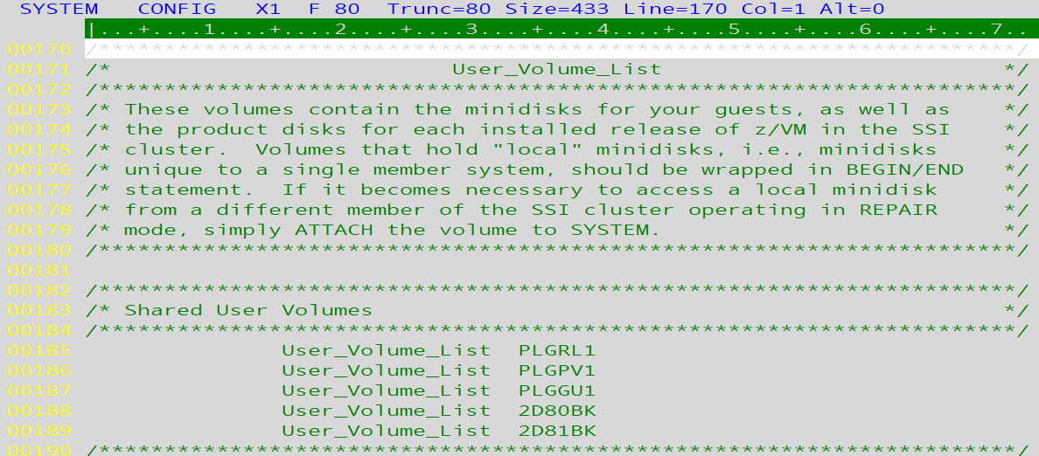

Virtual_switch_definitions  
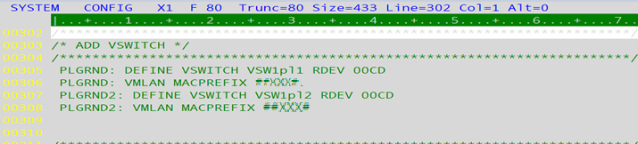

Merge

Merging User Direct



* Source System will refer to the, “old” in the case of upgrades.
* Target System will refer to the, “new” system.

1. Pull down a User Withpass from the Target and Source systems. When receiving the file name them; Source and Target respectively with the filetype Direct.  
   ex. Source system:
   1. DIRM operand  
      DIRM user withpass  
      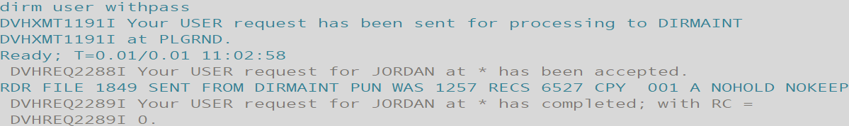
   2. Receive fileid filename filetype filemode (options  
      Receive 1849 target direct a   
      
      1. User Direct is located on PMAINT 2CC if you’d like to manually grab the file.
2. Merge the source and target system’s user directories into a single composite directory on the source system using; **DRCTLIST****,** **DRCTPRUN**and**DRCTCOMP**as instructed below:
   1. Verify REXX exec “**DRCTLIST** EXEC A” uses proper inputs for SOURCEIN and TARGETIN file names and execute to create, “MIGRATE USERLIST A”.  
      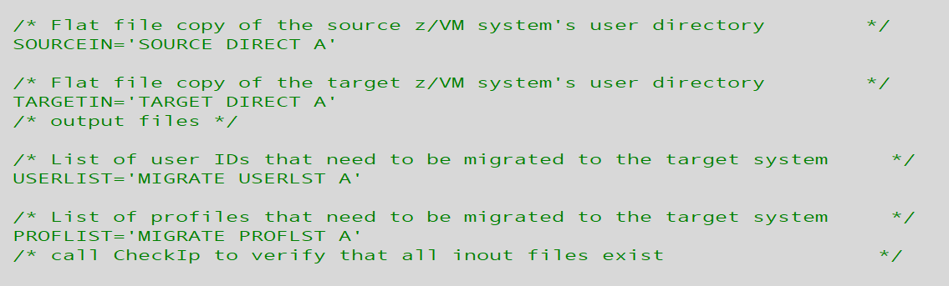
   2. Execute DRCTLIST to list user names

* + 1. **DRCTLIST**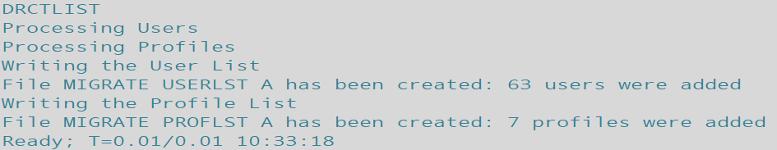
  1. Execute REXX exec “**DRCTPRUN**” to ‘prune’ ”MIGRATE USERLIST A” list into “MIG$NEW USERLST A”.

* + 1. **DRCTPRUN**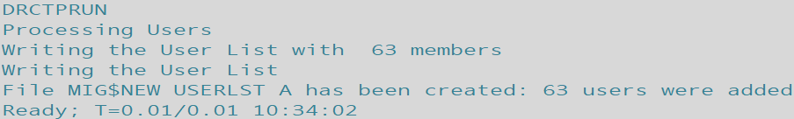
  1. Edit “MIG$NEW USERLST A” – verify expected user entries appear; watch for $SYSTEM$ entry – has been a list of z/VM system volumes. Remove release-specific users such as:

6VMDIR10

6VMPTK10

6VMRAC10

6VMRSC10

6VMTCP10

(Also MAINT620 and any duplicates from USER/IDENTITY matchup).

* 1. Execute REXX exec “**DRCTCOMP**” – verify proper inputs used.

* + 1. **DRCTCOMP**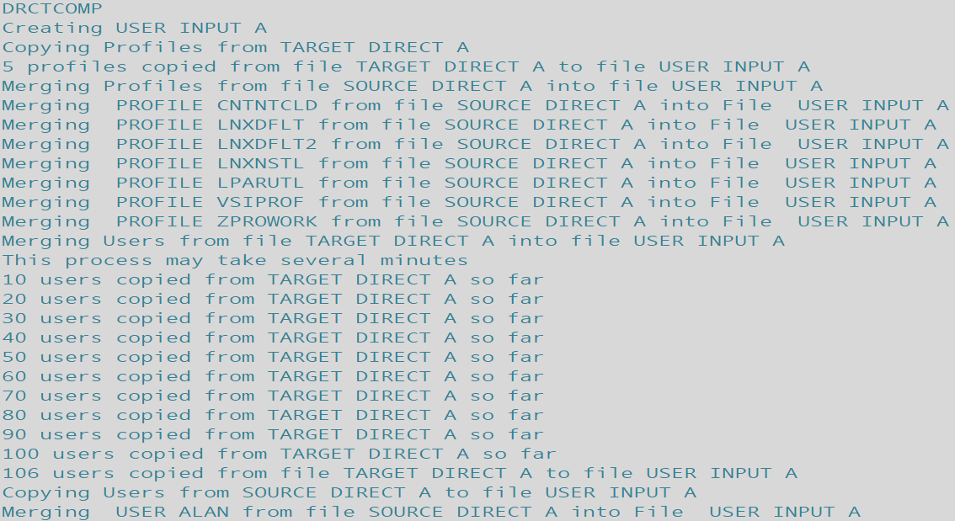  
       (continues for all the users not present on both systems.)  
       

1. Open USERINPUTA in XEDIT and check the banner comment at the top for the version. Verify correct entry types while watching for duplicate ‘USER’ & ‘IDENTITY’ definitions.
   1. Xedit filename filetype filemode  
      X user input a  
      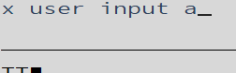

Consult the DIRM Batch Update instructions to apply a monolithic directory placing it in production.

Merge

Batch

DIRM Batch Direct Update****

1. Place User Input on MAINT730’s 191 disk for easy access.
2. Log onto DIRMAINT.
3. Save the file as User Input to DIRMAINT’s 1DF MDISK (alternative file it there with DIRM file.)
   1. VMLINK USER MDISK  
      vmlink maint730 191  
      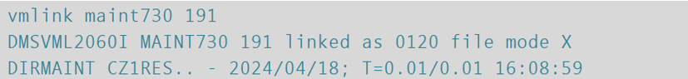
   2. Copyfile filename filetype filemode *new*filename *new*filetype *new*filemode (options  
      Copyfile user input x *user* *input* *e* (options  
      
   3. Rename User Direct to preserve it and prevent it from being used to build the directory.  
      Rename / *new*filename *new*filetype *new*filemode  
      Rename / *user* *oldirect* *e*  
      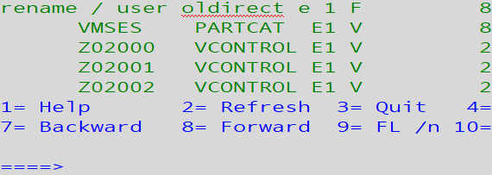
      1. Or alternatively:  
         Rename filename filetype filemode newFN newFT newFM  
         Rename user direct e user oldirect e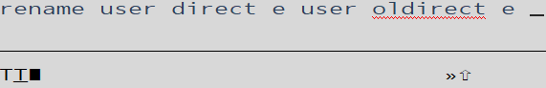
4. From DIRMAINT user submit Directxa command to check the user input file, edit it and then rebuild the directory from the user input file placed on DIRMAINT’s e disk (1df mdisk).
   1. First submit the directxa command using the edit option to find any issues with the file like syntax or floating characters on new lines.  
      directxa filename filetype filemode (options  
      directxa user input e (edit  
      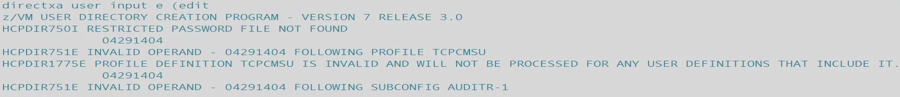
      1. In this example several lines containing, “04291404” were pushed onto new lines during the transfer of the new direct file. This number is normally invisible within columns 73-80. While strange it does not cause any harm once removed.
      2. “Restricted password file not found” may be ignored.
   2. Take note of all discrepancies named by the directxa command. Open xedit or an editor and remove the problem lines.  
      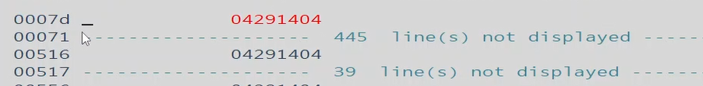
      1. D is used here in the column to remove a full line.
   3. It helps to do a search using the ‘/’ xedit search command and ‘all’ option for ‘all occurrences’ when removing items.  
      option /searchterm  
      all /0429  
      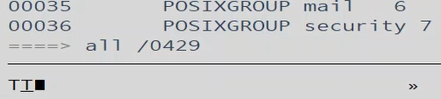
      1. As shown in the image above example user is searching for the flagged items found by directxa’s edit.
   4. Once all the items have been removed run the directxa edit option command again to check your work.   
      directxa filename filetype filemode (options  
      directxa user input e (edit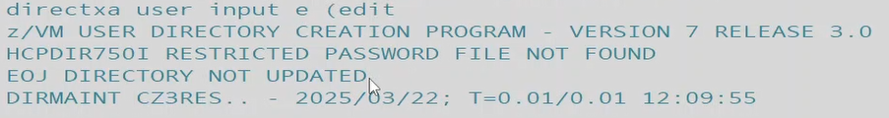
      1. “Restricted password file not found” may be ignored.
   5. Now the file is clean and may be used to rebuild the directory. Submit the same directxa command without the edit option.  
      directxa filename filetype filemode  
      directxa user input e  
      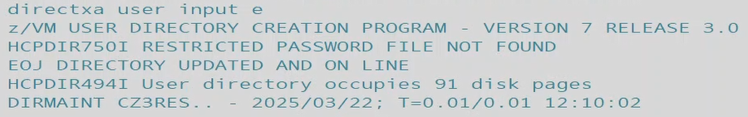
   6. Bring the changes online and place DIRMAINT back in service with DVHBEGIN.  
      DVHBEGIN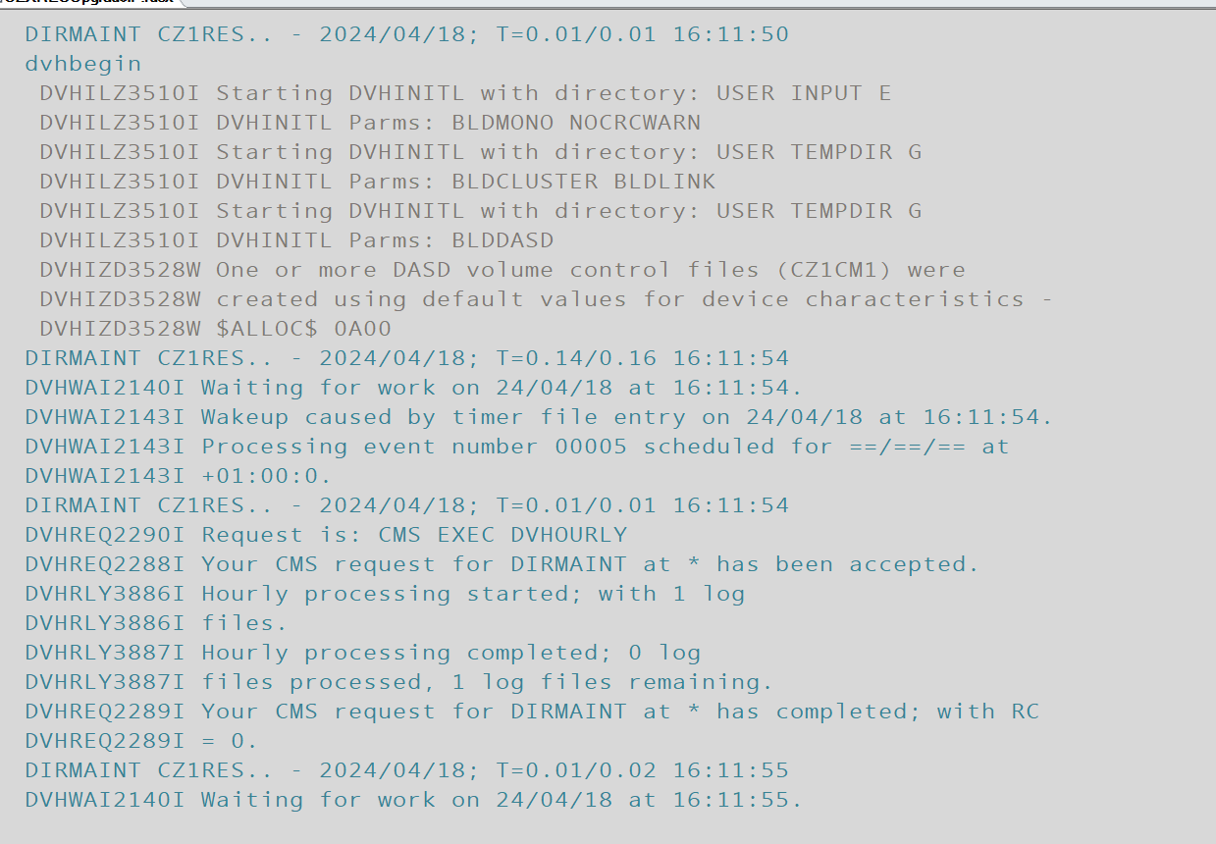
5. Disconnect from DIRMAINT and leave it running.  
   #cp command  
   #cp disconnect  
   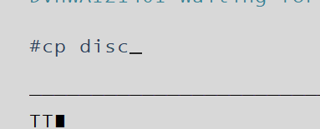
6. Test the changed by logging onto a user expected to have been added.

Batch

System Upgrade and Guest Migration 2nd Level

|  |  |  |  |  |  |  |  |  |  |  |  |  |  |
| --- | --- | --- | --- | --- | --- | --- | --- | --- | --- | --- | --- | --- | --- |
| |  | | --- | | Document Legend |   C:\Users\P00341017\Documents\JA FileZ\Key Information\Misc Office\Jordan's Document Command Legend.png   * O The Structure / Syntax line displays the structure of the command and labels the parts. * O Example Command lines are verbatim or previously used command inputs that can actually be used or copied. * O Input / Output lines contain real images of the command in use, often showing context. * Purple highlights denote commands. * Red highlights denote user supplied or contextually dictated values. * Blue highlights denote options or operands that change how commands function. * Some commonly used abbreviations:  |  |  |  |  |  |  | | --- | --- | --- | --- | --- | --- | | Fn | Ft | Fm | Vdev | Mdisk | Mode | | Filename | Filetype | Filemode | Virtual Device Address | Minidisk | Disk Label, Read/write permissions | |

1. Establish downtime for Applications that run on the Source System for upgrading. Provide detailed information to the respective teams for awareness and accurate approvals. Confirm time frame **multiple** times.
   1. Specifically address at what time *other parties are to begin bringing systems down in relation to downtimes. For example applications on a Linux guest, speak with the party responsible for bringing these applications down directly to specify at what exact time they should begin bringing these things down.
   2. Establish how progress and problems will be communicated to the relevant parties.
   3. Communicate what steps will be taken should issues arise.
   4. Plan a backup timeframe for a second attempt, or repair/revert procedures.
2. Fill Worksheet(s) with relevant guest machine information to act as progressive checklists/logs of actions taken, Swap Procedure will cover the steps after the Server Backup Log worksheet’s backups/shell tests are done.
3. Shutdown virtual machine guests.  
   Signal command user  
   Signal shutdown mi99la40  
   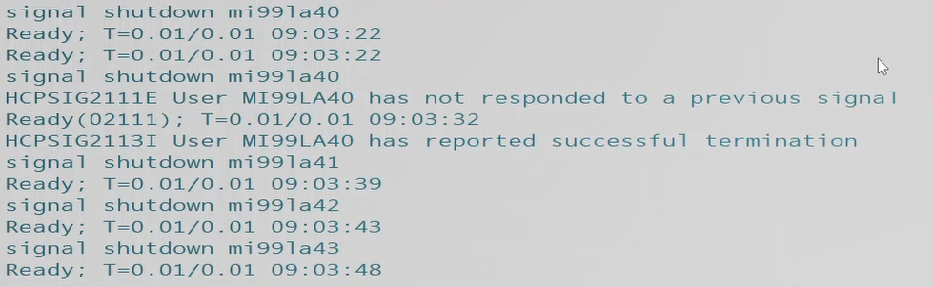
   1. Submit a Query Name to verify all guests are shutdown  
      Query Name  
      q n  
      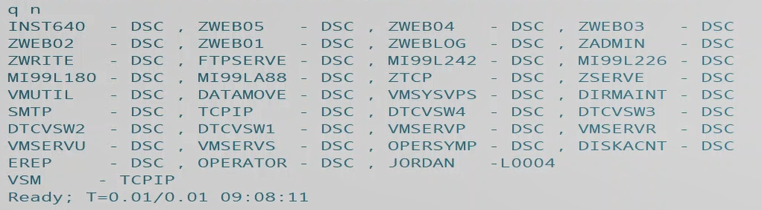
4. Logon by each guest and perform backups (using premade scripts, in accordance with the <worksheets> filled out previously. Special attention to be paid to **which** scripts to use. This will be decided by the vdev addresses for backup MDISKS.)
   1. Use Copy_STD as relevant. (Consult your Worksheet!)  
      copy_std  
      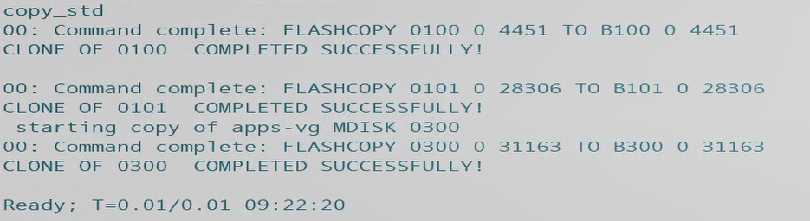
   2. Use Copy_B01 as relevant.  
      copy_b01
   3. Use Copy_B03 as relevant.  
      copy_b03
   4. Use Copyos as relevant.  
      copyos  
      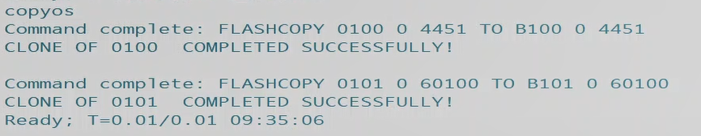
      1. Note any error given as messages will be given if devices are unavailable at logon or the backup scripts are not able to run due to DASD or MDISK being unavailable.  
         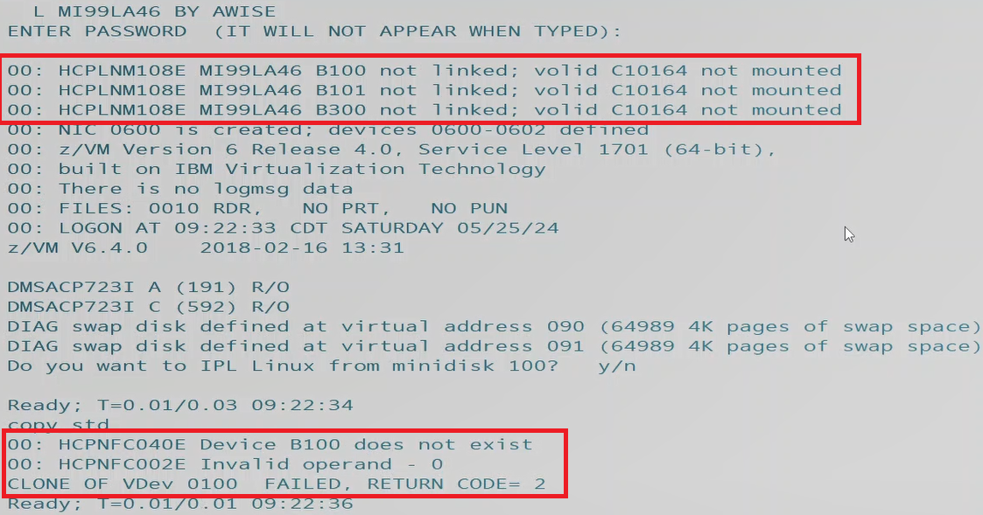
      2. Use direct entries as cross references for locating the address of missing DASD or MDISKS. See below examples of MDISK statements.  
         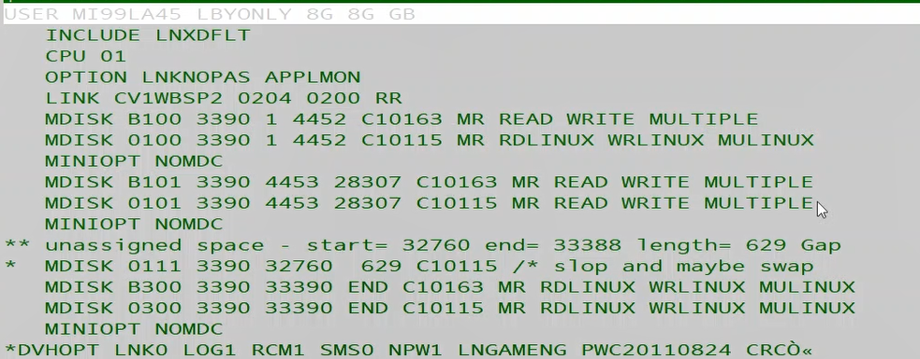
      3. If errors are given for missing DASD for copying – submit a Query DASD to identify missing DASD containing relevant MDISKs.  
         Query operand volid  
         Q dasd c10164  
         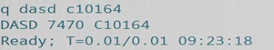
      4. Submit Vary Online commands before attempting to attach devices (just in case for the most part, pre-emptive.)  
         vary operand vdev  
         vary online 7470-747f  
         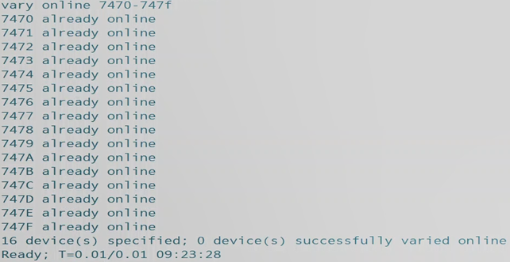
      5. Attach any missing DASD for the backup scripts to function correctly and the guests/system to have access.  
         attach vdev operand  
         att 7470-747f to system  
         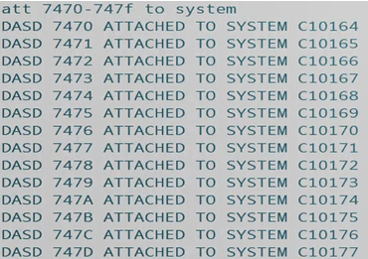
5. Log onto the Target system (being hosted second level on a placeholder IP) and change the file name of the edited-in-waiting System Config file containing the tailored/desired values and parameters of the finished system. *Inspect and confirm all tailored lines are correct, VERY Important. Run a CPSYNTAX as well to be safe.
   1. Use VMLINK to establish a connection to pmaint cf0.  
      vmlink user mdisk (option  
      vmlink pmaint cf0 (write  
      
   2. Use filelist to view the files on the now linked pmaint cf0 mdisk.  
      Filelist filename filetype filemode  
      filel * * z  
      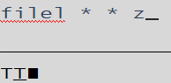
   3. Use VMLINK to establish access to the Maint 193 MDISK to utilize CPSYNTAX.  
      VMLINK user mdisk (option  
      VMLINK maint 193  
      
   4. Use CPSYNTAX to verify system config replacement file’s integrity.  
      CPSYNTAX filename filetype filemode  
      CPSYNTAX system confedit h  
      
   5. Rename or create a duplicate with a new name and discard the original system config.  
      Rename filename filetype filemode newFN newFT newFM (options  
      rename system config z system cnfgold z  
      
      1. Alternatively the user may use copyfile and discard the original, keeping the new copy with the new name.
6. Change the IP Address within PROFILE TCPIP to the Source System’s IP by VMLinking to the Target System’s TCPMAINT 198 MDISK.  
   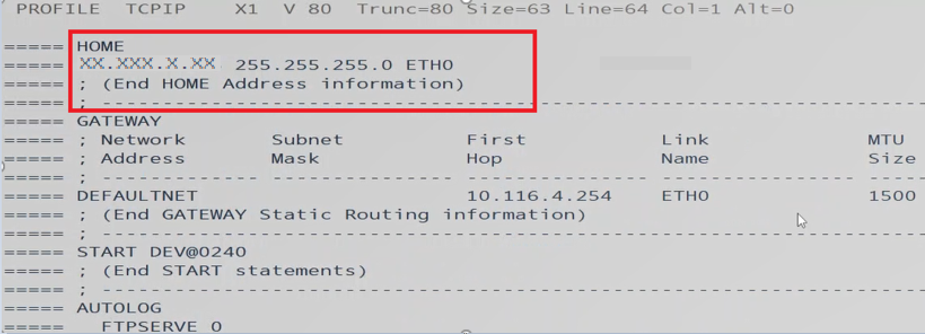
   1. Use VMLINK to access Profile TCPIP on TCPMAINT 198 MDISK.  
      VMLINK user mdisk (options  
      vmlink tcpmaint 198 (write  
      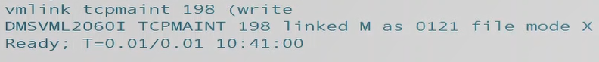
   2. List the files on TCPMAINT with Filelist (or open directly via xedit), and open the file for editing by placing an x in the left-hand command line margin once listed.  
      Filelist filename filetype filemode  
      filel * * x  
      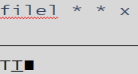
   3. Save and submit changes with the File command on xedit’s command line.  
      File  
      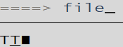
7. Log onto the HMC and bring down the Source System with an Integrated 3270 Terminal, freeing up the 1st Level and IP.  
   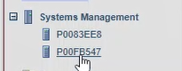  
   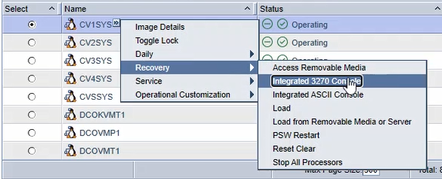  
   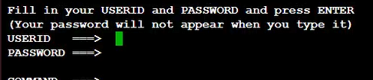
   1. Shutdown the Source System with a privileged user.Shutdown operand systemname operand  
      Shutdown System CV1RES  
      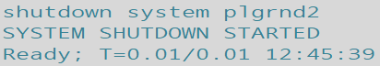
      1. The terminal will either disconnect after 10-30 seconds (try pressing <Enter> to prompt it into showing you’ve been disconnected,) or you’ll be placed in the lower environment and given a message saying the shutdown was successful.
   2. Confirm that the LPAR shows as Deactivated from the HMC view.  
      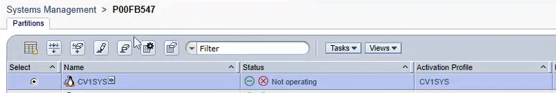
8. Bring up the Target System by specifying the “Load address” accessing the dropdown menu for the relevant system Recovery>Load: enter address.
   1. LPAR > Recovery > Load  
      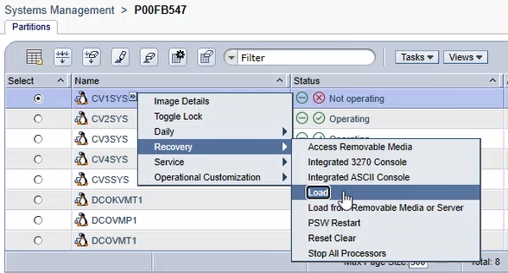
   2. Set the new Load address for the RES volume of the Target Upgraded System.  
      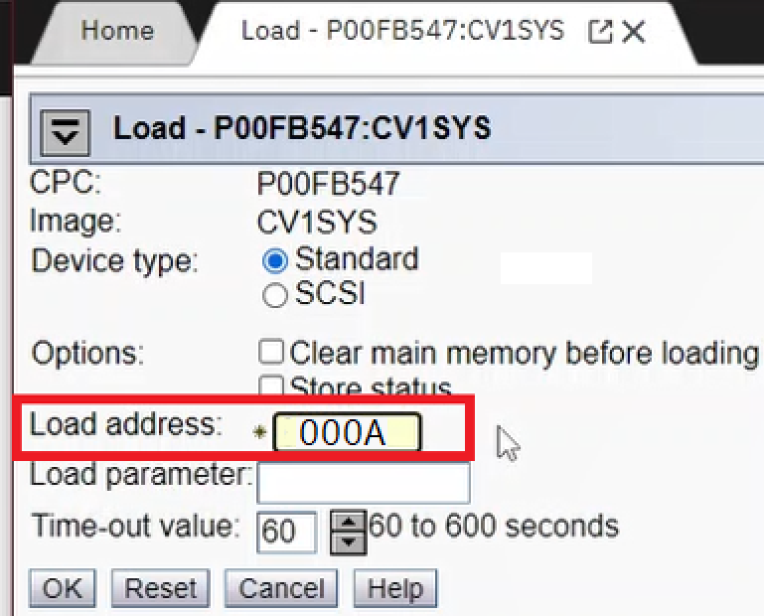
   3. Select. ‘Yes’ for Load Task Confirmation  
      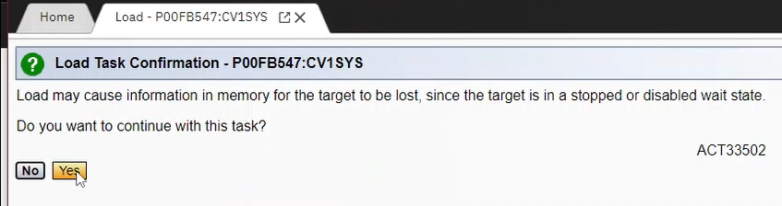
   4. **<CLICK>** the, ‘Yes’ confirmation for Disruptive Task Confirmation after inputting user password.  
      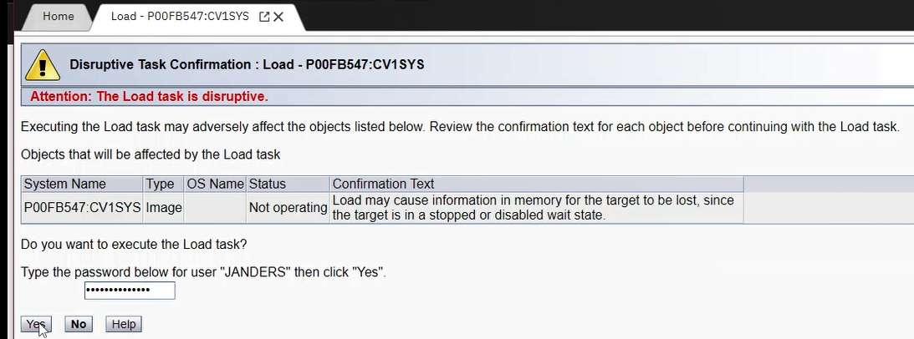
   5. Wait patiently for the Load Progress to finish.  
      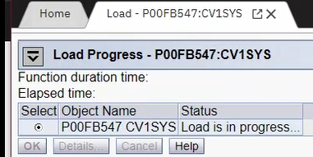
   6. Select, ‘OK’ for Load Progress after Load completes.  
      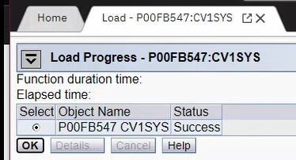
9. Log onto each Linux Guest with a privileged user with Logon By and submit, ‘Y’ for yes to IPL Linux from Minidisk. Wait for it to auto-select the correct following option (0, 1, and 2.)
   1. Logon user By user  
      L Mi99LA42 BY AWISE  
      
      1. Pay close attention to the output and progress of setup, configuration and the upcoming file system check.
   2. Submit, “Y” for Yes to IPLing Linux from Minidisk 100.  
      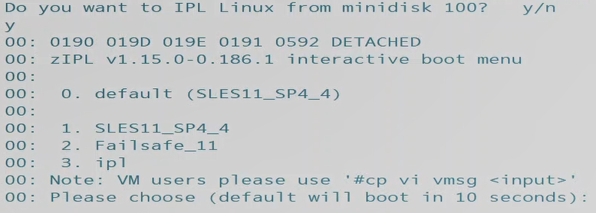
   3. Patiently wait for first time setup and file system checks to succeed and finish. This will take some time.  
      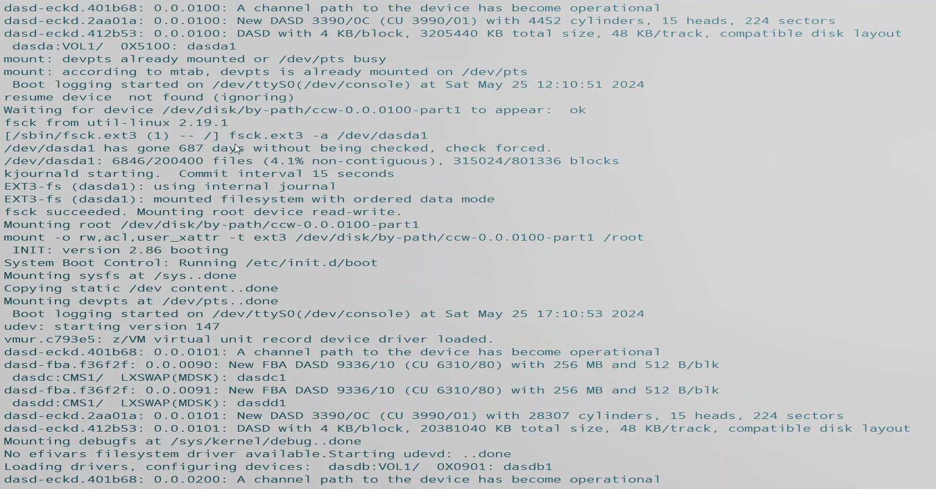
      1. There will be a great deal of screens like above and below – keep watch for suspicious output, nastygrams and error messages.  
         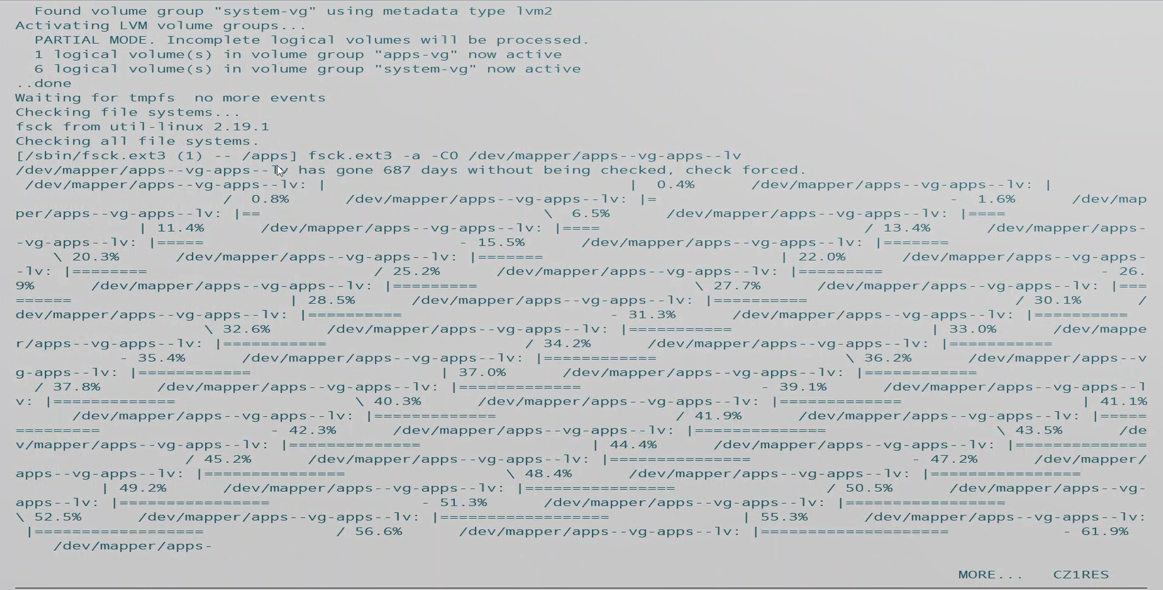
      2. The final output comprising the success of, ‘First Boot’ is the login credential request after checks succeed:  
         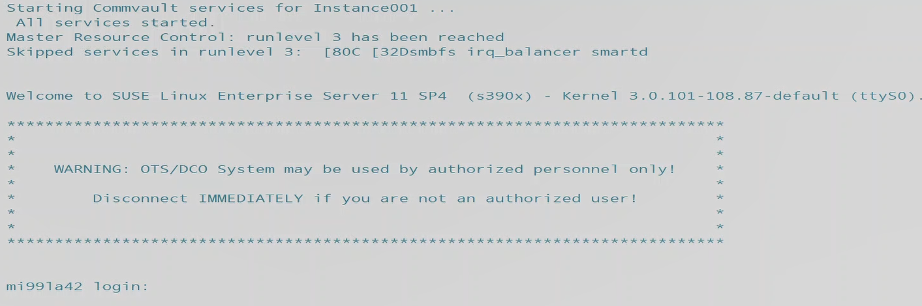
   4. Submit #CP Disconnect commands for the virtual machine guests after verifying it is possible to Login and First Boot succeeded.  
      #CP Command  
      #cp disc  
      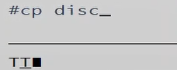
10. Submit Signal shutdowns to the virtual machine guests to bring them down for xautolog to bring them back online disconnected.
    1. Signal command user option  
       Signal shutdown mi99laxx within 30  
         
       
       1. Do this for each and every virtual machine guest, in accordance with your <VM Log> and confirm success.
    2. Confirm ALL guests have been cleanly shutdown with Signals via Q N command  
       Query Name  
       q n  
       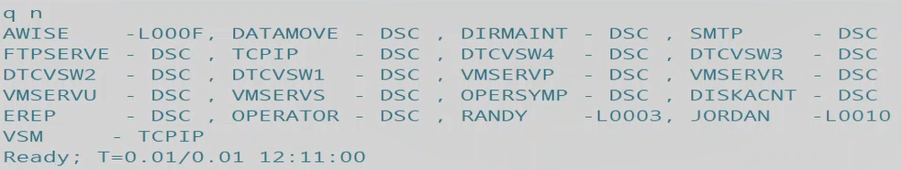
11. Once all Guests have been shut back down, log onto a privileged user able to submit commands to xautolog. Once logged in, submit xautolog commands for each Guest VM to be tested using a shell login.
    1. Xautolog name  
       Xautolog Mi99la40  
       
12. Confirm that all Guests are now present and xautologged successfully to a DSC disconnected state via Q N command.
    1. Query Name  
       q n  
       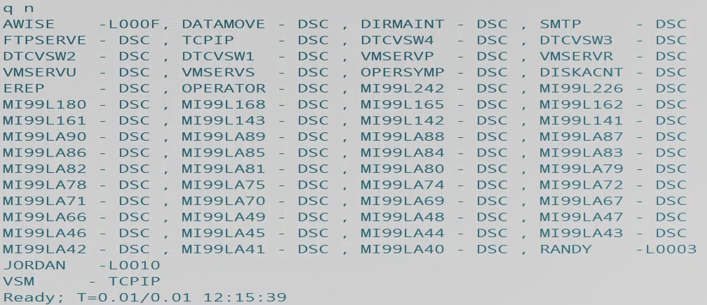
13. Once all Guests have been successfully Xautologged – test the ability to log into them via Shell (PuTTY for example.)

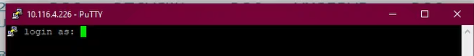

1. If you are able to successfully reach the login and command line within each guest machine, they are function and the upgrade/migration was a success!

Return to top of this Guide.

Server Backups Log

|  |  |  |  |  |  |  |  |  |  |
| --- | --- | --- | --- | --- | --- | --- | --- | --- | --- |
|  | DIRM on  Old Sys  complete | Signal  Shutdown | Linux  Server  Name |  | COPY_STD | COPY  Special | First boot | xautolog | ssh |
| 1 |  |  | Guestname |  | O |  |  |  |  |
| 2 |  |  | Guest |  | O |  |  |  |  |
| 3 |  |  | Guest |  | O |  |  |  |  |
| 4 |  |  | Guest |  | O |  |  |  |  |
| 5 |  |  | Guest |  | O |  |  |  |  |
| 6 |  |  | Guest |  | O |  |  |  |  |
| 7 |  |  | Guest |  | O |  |  |  |  |
| 8 |  |  | Guest |  | O |  |  |  |  |
| 9 |  |  | Guest |  | O |  |  |  |  |
| 10 |  |  | Guest |  | O |  |  |  |  |
| 11 |  |  | Guest |  | O |  |  |  |  |
| 12 |  |  | Guest |  | O |  |  |  |  |
| 13 |  |  | Guest |  | O |  |  |  |  |
| 14 |  |  | Guest |  | O |  |  |  |  |
| 15 |  |  | Guest |  | O |  |  |  |  |
| 16 |  |  | Guest |  | O |  |  |  |  |
| 17 |  |  | Guest |  | O |  |  |  |  |
| 18 |  |  | Guest |  | O |  |  |  |  |
| 19 |  |  | Guest |  | O |  |  |  |  |
| 20 |  |  | Guest |  | O |  |  |  |  |
| 21 |  |  | Guest |  | O |  |  |  |  |
| 22 |  |  | Guest |  | O |  |  |  |  |
| 23 |  |  | Guest |  | O |  |  |  |  |
| 24 |  |  | Guest |  | O |  |  |  |  |
| 25 |  |  | Guest |  | O |  |  |  |  |
| 26 |  |  | Guest |  | O |  |  |  |  |
| 27 |  |  | Guest |  | O |  |  |  |  |
| 28 |  |  | Guest |  | O |  |  |  |  |
| 29 |  |  | Guest |  | O |  |  |  |  |
| 30 |  |  | Guest |  | O |  |  |  |  |
| 31 |  |  | Guest |  | O |  |  |  |  |
| 32 |  |  | Guest |  | O |  |  |  |  |
| 33 |  |  | Guest |  | O |  |  |  |  |
| 34 |  |  | Guest |  | O |  |  |  |  |
| 35 |  |  | Guest |  | O |  |  |  |  |
| 36 |  |  | Guest |  | O |  |  |  |  |
| 37 |  |  | Guest |  | O |  |  |  |  |
| 38 |  |  | Guest |  | O |  |  |  |  |
| 39 |  |  | Guest |  | O |  |  |  |  |
| 40 |  |  | Guest |  | O |  |  |  |  |
| 41 |  |  | Guest |  | O |  |  |  |  |
| 42 |  |  | Guest |  | O |  |  |  |  |

Return

System Swap Procedure Log

|  |  |  |
| --- | --- | --- |
| Step 1 |  | Copy Linux servers following check list |
| Step 2 |  | Update System Config VSWITCH OSA addresses to match CV1RES addresses |
| Step 3 |  | Update ‘PROFILE TCPIP’ – HOME address (on TCPMAINT 198) |
| Step 4 |  | Login hmc –  Get integrated console open for Lpar CV1SYS under ‘Recovery’ option |
| Step 5 |  | Logon system CV1RES as any SYSADMIN UserID - ‘SHUTDOWN SYSTEM CV1RES’ |
| Step 6 |  | After shutdown completes –  open ‘Load’ profile under ‘Recovery’ option for CV1SYS and change ‘Load address’ to 0702D  and continue with ‘Load’ |

Return

COPY_STD

/* REXX SCRIPT TO Copy LINUX MINIDISKS 0100, 0101 and 0300 */

/* to B100, B101 and B300 */

/* */

ADDRESS COMMAND

"CP FLASHCOPY 0100 0 END TO B100 0 END "

IF RC <> 0 THEN DO

SAY 'CLONE OF VDev 0100 FAILED, RETURN CODE=' RC

EXIT

END

SAY 'CLONE OF 0100 COMPLETED SUCCESSFULLY!'

SAY ' '

"CP FLASHCOPY 0101 0 END TO B101 0 END "

IF RC <> 0 THEN DO

SAY 'CLONE OF VDev 0101 FAILED, RETURN CODE=' RC

EXIT

END

SAY 'CLONE OF 0101 COMPLETED SUCCESSFULLY!'

SAY ' starting copy of apps-vg MDISK 0300 '

"CP FLASHCOPY 0300 0 END TO B300 0 END "

IF RC <> 0 THEN DO

SAY 'CLONE OF VDev 0300 FAILED, RETURN CODE=' RC

EXIT

END

SAY 'CLONE OF 0300 COMPLETED SUCCESSFULLY!'

SAY ' '

EXIT

Return

COPY_B01

/* REXX SCRIPT - flashcopy MDISKS 0100, 0101, 0300 & 0301 */

/* to B100, B101, B300 & B301 */

/* */

ADDRESS COMMAND

"CP FLASHCOPY 0100 0 END TO B100 0 END "

IF RC <> 0 THEN DO

SAY 'CLONE OF VDev 0100 FAILED, RETURN CODE=' RC

EXIT

END

SAY 'CLONE OF 0100 COMPLETED SUCCESSFULLY!'

SAY ' '

"CP FLASHCOPY 0101 0 END TO B101 0 END "

IF RC <> 0 THEN DO

SAY 'CLONE OF VDev 0101 FAILED, RETURN CODE=' RC

EXIT

END

SAY 'CLONE OF 0101 COMPLETED SUCCESSFULLY!'

SAY ' starting copy of apps-vg MDISK 0300 '

"CP FLASHCOPY 0300 0 END TO B300 0 END "

IF RC <> 0 THEN DO

SAY 'CLONE OF VDev 0300 FAILED, RETURN CODE=' RC

EXIT

END

SAY 'CLONE OF 0300 COMPLETED SUCCESSFULLY!'

SAY ' '

SAY ' starting copy of apps-vg MDISK 0301 '

"CP FLASHCOPY 0301 0 END TO B301 0 END "

IF RC <> 0 THEN DO

SAY 'CLONE OF VDev 0301 FAILED, RETURN CODE=' RC

EXIT

END

SAY 'CLONE OF 0301 COMPLETED SUCCESSFULLY!'

SAY ' '

EXIT

Return

COPY_B03

/* REXX SCRIPT - flashcopy MDISKS 0100, 0101, 0300 & 0303 */

/* to B100, B101, B300 & B303 */

/* */

ADDRESS COMMAND

"CP FLASHCOPY 0100 0 END TO B100 0 END "

IF RC <> 0 THEN DO

SAY 'CLONE OF VDev 0100 FAILED, RETURN CODE=' RC

EXIT

END

SAY 'CLONE OF 0100 COMPLETED SUCCESSFULLY!'

SAY ' '

"CP FLASHCOPY 0101 0 END TO B101 0 END "

IF RC <> 0 THEN DO

SAY 'CLONE OF VDev 0101 FAILED, RETURN CODE=' RC

EXIT

END

SAY 'CLONE OF 0101 COMPLETED SUCCESSFULLY!'

SAY ' starting copy of apps-vg MDISK 0300 '

"CP FLASHCOPY 0300 0 END TO B300 0 END "

IF RC <> 0 THEN DO

SAY 'CLONE OF VDev 0300 FAILED, RETURN CODE=' RC

EXIT

END

SAY 'CLONE OF 0300 COMPLETED SUCCESSFULLY!'

SAY ' '

SAY ' starting copy of apps-vg MDISK 0303 '

"CP FLASHCOPY 0303 0 END TO B303 0 END "

IF RC <> 0 THEN DO

SAY 'CLONE OF VDev 0303 FAILED, RETURN CODE=' RC

EXIT

END

SAY 'CLONE OF 0303 COMPLETED SUCCESSFULLY!'

SAY ' '

EXIT

Return

COPYOS

/* REXX SCRIPT TO Copy LINUX MINIDISKS 0100 and 0101 */

/* to B100 and B101 */

/* TARGET MINIDISKS added to Linux servers */

/* */

/* note 'CP Commands' doc suggests extents must match - watch /apps */

/* - and - */

/* Guest FLASHCOPY support is restricted to dedicated */

/* or fullpack minidisks. */

/* */

ADDRESS COMMAND

"CP FLASHCOPY 0100 0 END TO B100 0 END "

IF RC <> 0 THEN DO

SAY 'CLONE OF VDev 0100 FAILED, RETURN CODE=' RC

EXIT

END

SAY 'CLONE OF 0100 COMPLETED SUCCESSFULLY!'

SAY ' '

"CP FLASHCOPY 0101 0 END TO B101 0 END "

IF RC <> 0 THEN DO

SAY 'CLONE OF VDev 0101 FAILED, RETURN CODE=' RC

EXIT

END

SAY 'CLONE OF 0101 COMPLETED SUCCESSFULLY!'

EXIT

Return

DASD Allocation (ex. Page volumes for guests.)

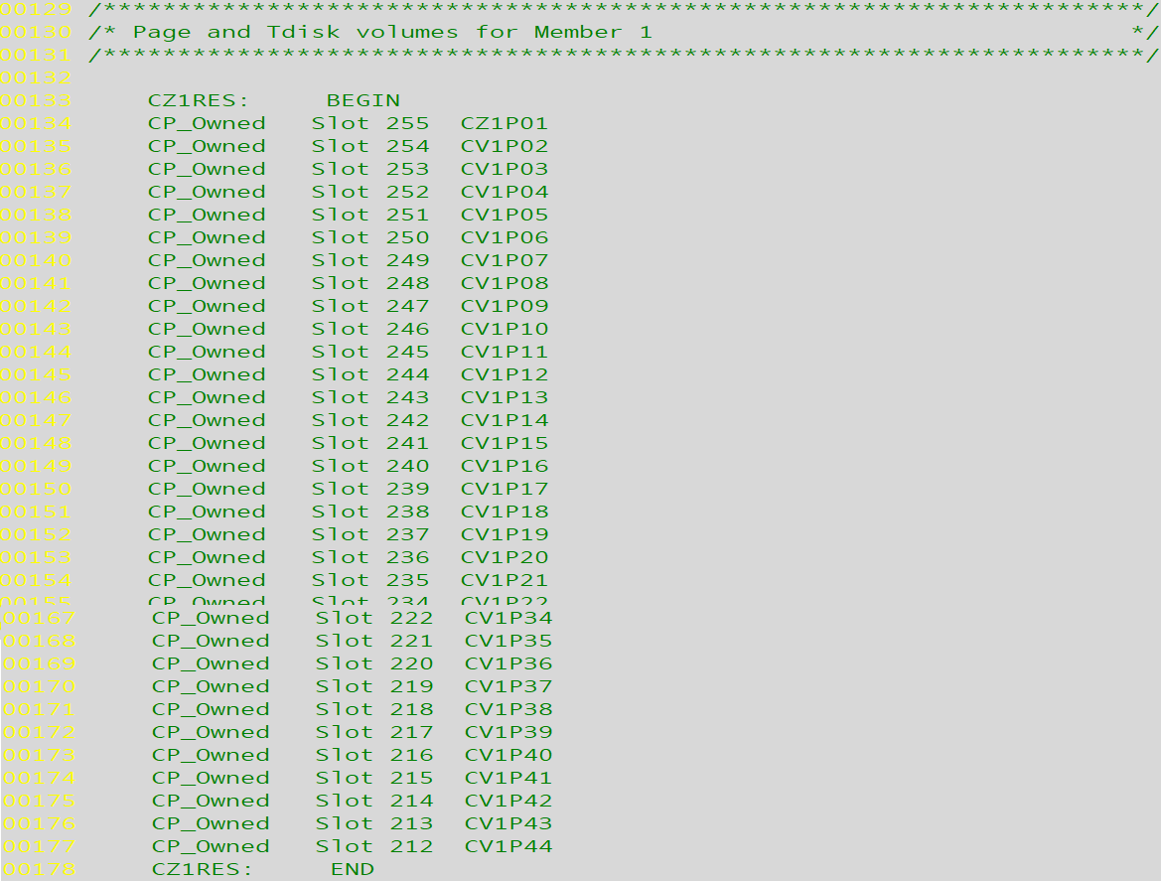

DASD Allocation

DRCTCOMP

/* DRCTCOMP - Create USER DIRECT file to be used to migrate user */

/* and profile directory entries from source z/VM system */

/* to the target z/VM system using DIRECTXA */

/* Change Log */

/* */

/* 12/11/12 Modified GETUSER procedure: */

/* Changed: Do until W1='USER' */

/* To: Do until W1='USER' | W1='IDENTITY' */

/* 11/21/13 Modified userlist for Alan's new file */

/* */

/* Runs on the target system */

/* input files */

/* List of profile entries to be migrated - created by exec DIRLIST */

PROFLIST='MIGRATE PROFLST A'

/* List of user entries to be migrated - created by exec DIRLIST */

USERLIST='MIG$NEW USERLST A'

/* Flat file copy of the source z/VM system's user directory */

SOURCEIN='SOURCE DIRECT A'

/* Flat file copy of the target z/VM system's user directory */

TARGETIN='TARGET DIRECT A'

/* output file - USER INPUT A - becomes input to DIRECTXA or DVHBEGIN */

USERDIR='USER INPUT A'

/* call CheckIp to verify that all inout files exist */

Call CheckIp

/* erase the output file if it exists */

ADDRESS COMMAND 'ESTATE 'USERDIR  
If RC = 0 then 'ERASE 'USERDIR

/* create a new output file - must have RECFM F */

Say 'Creating 'USERDIR

'EXECIO 1 DISKW 'USERDIR' 0 F 80 (STRING *'

/* Get the DIRECTORY and GLOBALDEFS entries */

'pipe < ' TARGETIN,

'| specs 1-72 1',

'| pad 80',

'| block 80 fixed',

'| strtolabel /PROFILE/',

'| >> ' USERDIR

/* Copy profiles from flat file copy of the target z/VM system's user */

/* directory file to output file */

Say 'Copying Profiles from 'TARGETIN

Call GetProfs

/* Copy profiles to the output file using the GetDir procedure */

/* Note: profiles must be copied first to insure they are present */

/* when the user entries are processed */

'pipe < 'PROFLIST' | stem PROFS.'

Say 'Merging Profiles from file 'SOURCEIN' into file 'USERDIR

Do P = 1 to PROFS.0

NAME=PROFS.P

Call GetDir

End

/* Copy profiles from flat file copy of the target z/VM system's user */  
/* directory file to output file */

Say 'Merging Users from file 'TARGETIN' into file 'USERDIR

Say 'This process may take several minutes'

Call GetUsers

/* Copy user entries to the output file using the GetDir procedure */

'pipe < 'USERLIST' | stem USERS.'

Say 'Copying Users from 'SOURCEIN' to file 'USERDIR

Do U = 1 to USERS.0

NAME=USERS.U

Call GetDir

End

Say "File "USERDIR" has been created"

Exit

GetDir:

/* extract USER or PROFILE entries from the DIRM WITHPASS file */

/* and place into the output file */

Linein(SOURCEIN,1,0)

Do Forever

LINE=Linein(SOURCEIN)

Parse var LINE W1 W2 .

If W1='USER' & W2 = NAME | W1='PROFILE' & W2 = NAME then Do

'pipe var LINE | specs 1-72 1 | pad 80',

'| block 80 fixed | >> ' USERDIR

Say "Merging " W1 W2 "from file "SOURCEIN" into File " USERDIR

Do Forever

LINE=Linein(SOURCEIN)  
 'pipe var LINE | specs 1-72 1 | pad 80',

'| block 80 fixed | >> ' USERDIR

Parse var LINE L1 .

If L1 = "*DVHOPT" then Return

End /* copy records loop */

End /* if found loop */

End /* main loop */

Return

GetProfs:

/* Extract PROFILE entries from the Target System DIRM WITHPASS file */

/* and place into the output file */

Prof_Count=0

Save_Count=0

Linein(TAREGTIN,1,0)

Do Until LINES(TARGETIN)=0 | W1='USER'

LINE=Linein(TARGETIN)

Parse var LINE W1 .

If W1='PROFILE' | W1='Profile' then Do

'pipe var LINE | specs 1-72 1 | pad 80',

'| block 80 fixed | >> ' USERDIR

Prof_Count=Prof_Count+1

/*Do Until LINES(TARGETIN)=0 | W1='*DVHOPT' | W1='USER' */

Do Until LINES(TARGETIN)=0 | W1='USER'

LINE=Linein(TARGETIN)

Parse var LINE W1 .

If W1='PROFILE' | W1='Profile' then Prof_Count=Prof_Count+1

If W1 <> 'USER' then 'pipe var LINE | specs 1-72 1 | pad 80',  
 '| block 80 fixed | >> ' USERDIR

If Prof_Count=Save_Count+10 then Do

Say Prof_Count" profiles copied so far from "TARGETIN

Save_Count=Prof_Count

End

End

End /* copy loop */

End /* Main loop */

Say Prof_Count" profiles copied from file "TARGETIN" to file "USERDIR

Return

GetUsers:

/* Extract USER entries from the Target Systems DIRM WITHPASS file */

/* and place into the output file */

User_Count=0

Save_Count=0

Linein(TARGETIN,1,0)

Do until W1='USER'| W1='IDENTITY'

LINE=Linein(TARGETIN)

Parse var LINE W1 .

End

'pipe var LINE | specs 1-72 1 | pad 80',

'| block 80 fixed | >> ' USERDIR

User_Count=User_Count+1

Do Until LINES(TARGETIN)=0  
 LINE=Linein(TARGETIN)

Parse var LINE W1 .

If W1="USER" | W1="IDENTITY" then User_Count=User_Count+1

'pipe var LINE | specs 1-72 1 | pad 80',

'| block 80 fixed | >> ' USERDIR

If User_Count=Save_Count+10 then Do

Say User_Count" users copied from "TARGETIN" so far"

Save_Count=User_Count

End

End

Say User_Count" users copied from file "TARGETIN" to file "USERDIR

Return

CheckIp:

/* check for the input files - exit with RC 04 if not found */

IFiles.1=PROFLIST

IFiles.2=USERLIST

IFiles.3=SOURCEIN

IFiles.4=TARGETIN

IFiles.0=4

Do C=1 to IFiles.0

ADDRESS COMMAND 'ESTATE 'IFiles.C

If RC <> 0 then Do

Say 'Input file 'IFiles.C' not found - terminating'

Exit 4

End

End

Return

Return to instructions

DRCTLIST

/* DRCTLIST - create lists of unique users and profiles that need to */

/* be migrated to the system directory on the target system */

/* Runs on the target system */

/* input files */

/* Flat file copy of the source z/VM system's user directory */

SOURCEIN='SOURCE DIRECT A'

/* Flat file copy of the target z/VM system's user directory */

TARGETIN='TARGET DIRECT A'

/* output files */

/* List of user IDs that need to be migrated to the target system */

USERLIST='MIGRATE USERLST A'

/* List of profiles that need to be migrated to the target system */

PROFLIST='MIGRATE PROFLST A'

/* call CheckIp to verify that all inout files exist */

Call CheckIp

/* erase the output files if they exist */

ADDRESS COMMAND 'ESTATE 'USERLIST

If RC = 0 then 'Erase 'USERLIST

ADDRESS COMMAND 'ESTATE 'PROFLIST

If RC = 0 then 'Erase 'PROFLIST

Say 'Processing Users'

/* extract user names from new z/VM system's directory */

'pipe < 'TARGETIN' | locate 1-9 /USER /',

'| specs word 2 1 | sort | stem NUSERLST.'

/* extract user names from source z/VM system's directory */  
'pipe < 'SOURCEIN' | locate 1-9 /USER /',

'| specs word 2 1 | sort | stem PUSERLST.'

Say 'Processing Profiles '

/* extract profile names from target z/VM system's directory */

'pipe < 'TARGETIN' | locate 1-11 /PROFILE / | nlocate 1 /*/',

'| specs word 2 1 | sort | stem NPROFLST.'

/* extract profile names from source z/VM system's directory */

'pipe < 'SOURCEIN' | locate 1-11 /PROFILE / | nlocate 1 /*/',

'| specs word 2 1 | sort | stem PPROFLST.'

Say 'Writing the User List'

addctr=0

found=0

/* extract unique user IDs from the source z/VM system */

Do m = 1 to PUSERLST.0

Do x = 1 to NUSERLST.0

If NUSERLST.x =PUSERLST.m then found=1

End

If found=0 then Do

addctr=addctr+1

adduser.addctr=PUSERLST.m

End

found=0

End

/* write the list of unique user IDs from the source z/VM */  
/* system to the output file */

adduser.0=addctr

'pipe stem adduser. | >> 'USERLIST

Say "File "USERLIST" has been created: "adduser.0" users were added"

profctr=0

found=0

/* extract unique profile IDs from the source z/VM system */

Do m = 1 to PPROFLST.0

Do x = 1 to NPROFLST.0

If NPROFLST.x =PPROFLST.m then found=1

End

If found=0 then Do

profctr=profctr+1

addprof.profctr=PPROFLST.m

End

found=0

End

/* write the list of unique profiles from the source z/VM */

/* system to the output file */

Say 'Writing the Profile List'

addprof.0=profctr

'pipe stem addprof. | >> 'PROFLIST

Say "File "PROFLIST" has been created: "addprof.0" profiles were added"

Exit

CheckIp:

/* check for the input files - exit with RC 04 if not found */

IFiles.1=SOURCEIN

IFiles.2=TARGETIN

IFiles.0=2

Do C=1 to IFiles.0

ADDRESS COMMAND 'ESTATE 'IFiles.C

If RC <> 0 then Do

Say 'Input file 'IFiles.C' not found - terminating'

Exit 4

End

End

Return

Return to instructions

DRCTPRUN

/* DRCTPRUN - 'prune' list of user entries from MIGRATE USERLST A */

/* that should not move to new system */

/* Runs on the target system. MAINT620 */

/* input files */

/* Flat file from EXEC DRCTLIST EXEC - to be replaced */

SOURCEIN='MIGRATE USERLST A'

/* output file */

/* List of user IDs that need to be migrated to the target system */

USEROUT='MIG$NEW USERLST A'

/* build list of user names NOT to migrate to new system */

Call Excld_Lst

/* call CheckIp to verify that all inout files exist */

Call CheckIp

/* erase the output files if they exist */

ADDRESS COMMAND 'ESTATE 'USEROUT

If RC = 0 then 'Erase 'USEROUT

Say 'Processing Users'

/* get list of unique user names from system directory */

'pipe < 'SOURCEIN' | specs word 1 1 | sort | stem NUSERLST.'

Say "Writing the User List with " NUSERLST.0" members"

Say 'Writing the User List'

addctr=0

found=0

/* match derived users to drop-list and remove matching */

Do m = 1 to NUSERLST.0

Do x = 1 to DROPUSR.0

If NUSERLST.m =DROPUSR.x then found=1  
 End

If found=0 then Do

addctr=addctr+1

adduser.addctr=NUSERLST.m

End

found=0

End

/* write the list of unique user IDs from the source z/VM */

/* system to the output file */

adduser.0=addctr

'pipe stem adduser. | >> 'USEROUT

Say "File "USEROUT" has been created: "adduser.0" users were added"

Exit

CheckIp:

/* check for the input files - exit with RC 04 if not found */

IFiles.1=SOURCEIN

IFiles.0=1

Do C=1 to IFiles.0

ADDRESS COMMAND 'ESTATE 'IFiles.C

If RC <> 0 then Do

Say 'Input file 'IFiles.C' not found - terminating'

Exit 4

End

End

Return

Excld_Lst:

/* build list of user names NOT to migrate to new system */  
xi=0;

xi=xi+1; DROPUSR.xi ='VSMSERVE';

xi=xi+1; DROPUSR.xi ='GCSXA';

xi=xi+1; DROPUSR.xi ='5VMHCD40';

xi=xi+1; DROPUSR.xi ='TFTPD';

xi=xi+1; DROPUSR.xi ='NAMESRV';

xi=xi+1; DROPUSR.xi ='X25IPI';

xi=xi+1; DROPUSR.xi ='NDBPMGR';

xi=xi+1; DROPUSR.xi ='NDBSRV01';

xi=xi+1; DROPUSR.xi ='SNALNKA';

xi=xi+1; DROPUSR.xi ='VMKERB';

xi=xi+1; DROPUSR.xi ='ADMSERV';

xi=xi+1; DROPUSR.xi ='SSLSERV';

xi=xi+1; DROPUSR.xi ='AUDITOR';

xi=xi+1; DROPUSR.xi ='AUTOLOG1';

xi=xi+1; DROPUSR.xi ='AUTOLOG2';

xi=xi+1; DROPUSR.xi ='AVSVM';

xi=xi+1; DROPUSR.xi ='CBDIODSP';

xi=xi+1; DROPUSR.xi ='CMSBATCH';

xi=xi+1; DROPUSR.xi ='DHCPD';

xi=xi+1; DROPUSR.xi ='DISKACNT';

xi=xi+1; DROPUSR.xi ='DTCVSW1';

xi=xi+1; DROPUSR.xi ='DTCVSW2';

xi=xi+1; DROPUSR.xi ='EREP';

xi=xi+1; DROPUSR.xi ='FTPSERVE';

xi=xi+1; DROPUSR.xi ='GCS';

xi=xi+1; DROPUSR.xi ='GSKADMIN';

xi=xi+1; DROPUSR.xi ='IMAP';

xi=xi+1; DROPUSR.xi ='IMAPAUTH';

xi=xi+1; DROPUSR.xi ='LDAPSRV';

xi=xi+1; DROPUSR.xi ='LGLOPR';

xi=xi+1; DROPUSR.xi ='LPSERVE';

xi=xi+1; DROPUSR.xi ='MAINT';

xi=xi+1; DROPUSR.xi ='MIGMAINT';  
xi=xi+1; DROPUSR.xi ='MIGMAINT';

xi=xi+1; DROPUSR.xi ='MONWRITE';

xi=xi+1; DROPUSR.xi ='MPROUTE';

xi=xi+1; DROPUSR.xi ='OPERATNS';

xi=xi+1; DROPUSR.xi ='OPERATOR';

xi=xi+1; DROPUSR.xi ='OPERSYMP';

xi=xi+1; DROPUSR.xi ='OP1';

xi=xi+1; DROPUSR.xi ='OSADMIN1';

xi=xi+1; DROPUSR.xi ='OSADMIN2';

xi=xi+1; DROPUSR.xi ='OSADMIN3';

xi=xi+1; DROPUSR.xi ='OSAMAINT';

xi=xi+1; DROPUSR.xi ='OSASF';

xi=xi+1; DROPUSR.xi ='PERFSVM';

xi=xi+1; DROPUSR.xi ='PORTMAP';

xi=xi+1; DROPUSR.xi ='RACFSMF';

xi=xi+1; DROPUSR.xi ='RACFVM';

xi=xi+1; DROPUSR.xi ='RACMAINT';

xi=xi+1; DROPUSR.xi ='REXECD';

xi=xi+1; DROPUSR.xi ='RSCS';

xi=xi+1; DROPUSR.xi ='RSCSAUTH';

xi=xi+1; DROPUSR.xi ='RSCSDNS';

xi=xi+1; DROPUSR.xi ='RXAGENT1';

xi=xi+1; DROPUSR.xi ='SMTP';

xi=xi+1; DROPUSR.xi ='SNMPD';

xi=xi+1; DROPUSR.xi ='SNMPQE';

xi=xi+1; DROPUSR.xi ='SNMPSUBA';

xi=xi+1; DROPUSR.xi ='SYSDUMP1';

xi=xi+1; DROPUSR.xi ='SYSMON';

xi=xi+1; DROPUSR.xi ='TCPIP';

xi=xi+1; DROPUSR.xi ='TCPMAINT';

xi=xi+1; DROPUSR.xi ='TSAFVM';

xi=xi+1; DROPUSR.xi ='UFTD';

xi=xi+1; DROPUSR.xi ='VMNFS';

xi=xi+1; DROPUSR.xi ='VMRMADMN';

xi=xi+1; DROPUSR.xi ='VMRMSVM';

xi=xi+1; DROPUSR.xi ='VMSERVR';  
xi=xi+1; DROPUSR.xi ='VMSERVS';

xi=xi+1; DROPUSR.xi ='VMSERVU';

xi=xi+1; DROPUSR.xi ='VMUTIL';

xi=xi+1; DROPUSR.xi ='VSMPROXY';

xi=xi+1; DROPUSR.xi ='VSMREQIN';

xi=xi+1; DROPUSR.xi ='VSMREQIU';

xi=xi+1; DROPUSR.xi ='VSMWORK1';

xi=xi+1; DROPUSR.xi ='VSMWORK2';

xi=xi+1; DROPUSR.xi ='VSMWORK3';

xi=xi+1; DROPUSR.xi ='XCHANGE';

xi=xi+1; DROPUSR.xi ='ZVMMAPLX';

xi=xi+1; DROPUSR.xi ='6VMDIR10';

xi=xi+1; DROPUSR.xi ='6VMPTK10';

xi=xi+1; DROPUSR.xi ='6VMRAC10';

xi=xi+1; DROPUSR.xi ='6VMRSC10';

xi=xi+1; DROPUSR.xi ='6VMTCP10';

xi=xi+1; DROPUSR.xi ='610RES';

DROPUSR.0 =xi ;

Return

Return to instructions